|  |  |  |
| --- | --- | --- |
| **المملكــــــــة الأردنيــــــــــة الهاشـــــــمية**  **وزارة التربــــــــــــية و التعلـــــــــــــــــيم**  **مديرية التربية و التعليم / لواء الجامعة**  **مدرســة علي رضا الركابي الاساسية للبنين** |  | **الفصل الدراسي الثاني :** 2017 / 2018  **المــــــــــادة :** اللغـــــــــــة الإنجليزيــــــــة  **مدة الاختبار : ساعة واحدة.**  **التاريــــــــخ :** / / 2018 |
| **الاختبار النهائي - الصف الرابع الأساسي** |

**الاسم:**.............................................................................................................**الشعبة :** ...............................

**Question One 5 Points**

**-Read the following text carefully and then answer all the questions below:**

We must plant more trees .Trees are very important .Trees are home for many animals and birds. They give us shade in the summer. They help to clean the air and give us wood and paper.

Every year on 15th January children plant trees. It is an important day. We sing songs; we take photos, and make videos. We watch the trees grow.

1. Are trees important? ____________Yes, they are._______________________________
2. Trees are home for many ___animals________ and __birds____________.
3. What do trees give us in summer? ______They give us shade____________________
4. Trees give us __wood______ and _____paper_______
5. Children plant trees on

a) 15th January b) 16th January c) 17th January

**Question Two 10 Points**

**A- Read and complete the sentences:**

|  |  |  |  |  |
| --- | --- | --- | --- | --- |
| **bridges** | **old** | **birds** | **big** | **Madaba** |

1- Last week Kareem and Samira went to --------Madaba-------.

2- The map is very---------old-------- and very ---big---------.

3- They saw-------bridges--------- over the Jordan River.

4- Kareem and Samira saw ----birds------------ and animals on the mosaic map

**B- Write the words with similar meaning:**

|  |
| --- |
| **Grandpa** , **Grandma** , **Mum** , **Dad** |

|  |  |  |
| --- | --- | --- |
| **1.** | Father | …………dad………………………………………………… |
|  | | |
| **2.** | Mother | …………mum………………………………………………… |
|  | | |
| **3.** | Grandfather | …………… grandpa ……………………………………………… |
|  | | |
| **4.** | Grandmother | ……………… grandma …………………………………………… |

**C- Put the following sentences in the correct order:**

____3__ You must water the plant.

___2___ You must put the plant in the ground.

__1____ You must dig a hole.

__4____ You must wait the plant to grow.

**Question Three 15 points**

**A- Choose the answer from those given to complete each:**

## 1- The planetarium is the ------------ room in the museum.

## a-big b- darker c- darkest

## 2 - ------------is your brother?

a-who b- when c-what

## 3 - ----------do you live?

a-what b- where c- when

## 4- Yesterday I ------------the library.

a-visit b- visiting c-visited

## 5 - Sereen is ---------------- than Akram.

a- tall b- taller c- tallest

6-What ---------------you do yesterday

a- do b- does c- did

**B- Complete the table:**

|  |  |
| --- | --- |
| **Present** | **Past** |
| find | Found |
| Buy | Bought |
| see | Saw |
| drive | Drove |

**C- Write the correct sentence under the picture:**

**We went to the museum We had a meal in a restaurant**

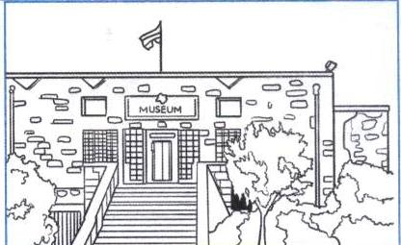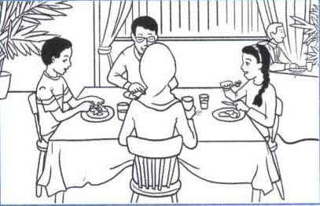

1. ____ **We had a meal in a restaurant** 2.  **We went to the museum**

**D -Complete the following:**

|  |  |  |
| --- | --- | --- |
| **ph** | **wr** | **kn** |

1- ele---ph---- ant 2 --wr----- ite

3 ----kn---- ee 4 ----ph---- one

**Question Four 10 Points**

**Answer the following questions:**

1- What is your name?

…………My name is ______________……………………………………….

2- Where do you live?

……I live in Amman.……………………………….

3- How old are you?

……I am ten /10 years old.………………………………..

4- What is your favorite food?

…………My favorite food is _________________………………………………………

THE END

WITH MY BEST WISHES