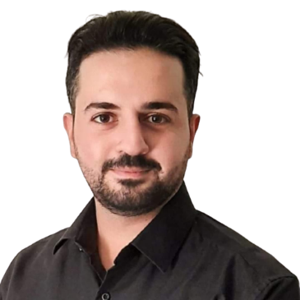

**Fadi Ahmad**

Doha , Qatar | +974**|**www.al-ehtiraf.com

[Contact@fadiahmad.com](mailto:Contact@fadiahmad.com)|[www.linkedin.com/in/fadi-ahmad](http://www.linkedin.com/in/fadi-ahmad)

**Professional Summary**

A professional site engineer with around 7 years of experience in the field, holder of a Bachelor’s degree in Civil Engineering and have attended multiple courses in the industry. Gained practical experience in sales, marketing and recruitment. Built an extensive online presence with LinkedIn to help job seekers with placement at companies.

**Professional strengths include:**

* Site Engineering
* Construction Works
* Shop Drawings
* Steel Structure
* Team Supervision
* Reporting
* AutoCAD
* STAAD Pro
* ETABS
* Prokon
* MS-Office
* G-Suite

# Experience

**Fadiahmad.com -** *Amman, Jordan*

***Freelancer* 02/2018 – Present**

* P
* A
* M
* D

**G -** *Amman, Jordan*

***Site Engineer* 01/2017 – 02/2018**

*The*

* A
* R
* S
* O

**Al- -** *Amman, Jordan*

***Supervisor Engineer* 08/2016 – 11/2016**

* S
* M

**F -** *Amman, Jordan*

***Supervisor Engineer* 04/2016 – 07/2016**

* W
* R

**Mini–** *Amman, Jordan*

***Intern* 01/2016 – 04/2016**

* O

# Education

**Bachelor’s Degree in Civil Engineering 12/2017**

# AlZarqa University – *Alzarqa, Jordan*

# Certifications

**Construction Supervision Training Program–** Jordan Engineers Association (JEA) **12/2017**

**Introduction to Safety Engineering –** Jordan Engineers Association (JEA) **12/2017**

**Reviewing Shop Drawings –** Jordan Engineers Association (JEA) **05/2017**

**Developing essential employability skills –** Dale Carnegie **05/2016**

**2D AutoCAD (R2007) –** Engineers Training Center **03/2013**

# Languages

**Arabic:** Native

**English:** Full Professional Proficiency