|  |  |  |
| --- | --- | --- |
| C:\Users\user\Downloads\20170618225634!شعار_وزارة_التربية_الأردنية.jpg | **second Trimester**  **First Test**  **School Year 2022-2023** | C:\Users\user\Downloads\download.png |

|  |  |  |  |  |
| --- | --- | --- | --- | --- |
| **Subject: computer** | |  | **Date …/……/2023** | |
| **Class& Section : 6th** | **Student’s Name:……………** | | |

**نموذج الاسئلة ( 5 )**

**Q 1 . switch on computer ( /1)**

**Q 2 . open the program Microsoft Excel ( /3)**

**Q 3 . insert the table four columns and five rows ( /4)**

|  |  |  |  |
| --- | --- | --- | --- |
| **Name** | **Grade** | **Hoppy** | **Mark** |
| **Zaid** | **1** | **Football** | **95** |
| **Awn** | **2** | **Swimming** | **90** |
| **Tarq** | **3** | **Darwing** | **85** |
| **Omar** | **4** | **Travel** | **80** |

**6**

**5**

**Q 4 . Write the Excel window components ( /10)**

**2**

**4**

**3**

**1**

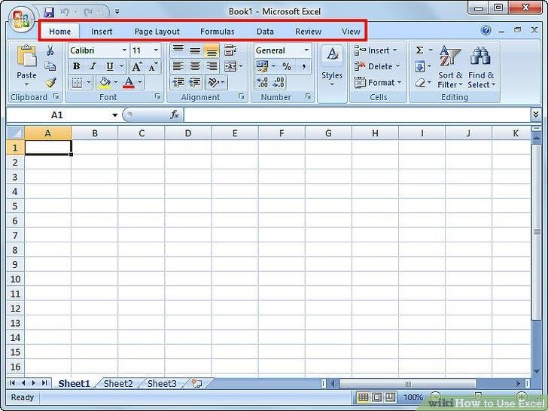

**7**

**8**

**10**

**9**

**Quick access toolbar / close / maximize / minimize / worksheet tabs / scroll bars / title bar / menu bar / toolbar / workbook .**

**1 ) ………………………………………**

**2 ) ………………………………………**

**3 ) ……………………………………….**

**4 ) ……………………………………….**

**5 ) ……………………………………….**

**6 ) …………………………………………**

**7 ) ………………………………………..**

**8 ) ………………………………………..**

**9 ) ………………………………………..**

**10 ) ………………………………………**

**Q 5 . save as the file your name ‘ sheet 1 ‘ ( /1)**

**Q 6 . close the Microsoft excel ( /1)**

**Good luck Teacher : Sae`da zreaqats**