Achievement Test for Diagnostic Purposes
2015/2016
Name: -------------------
Class: 4th grade Total: / 40

Speaking: 10 marks

Answer ( / 3):-
1. Can you jump very high? ------------------------------------
2. Do you drink cola? -----------------------------------------------------
3. When is your birthday? --------------------------------------------
- Match the sentence with its correct pictures: ( / 4 )
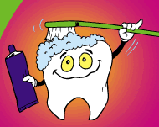
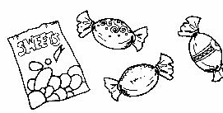
1. We must eat good food.
2. We mustn't eat a lot of sweets.
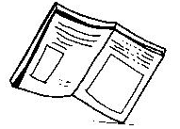
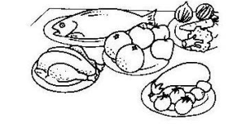
3. We must read good books.
4. We must clean our teeth.

- Odd one out: ( / 2 )
1. blouse dress cakes trousers
2. reading swimming buy running

C. Use ( / 1)
an
a

1. -------- egg.
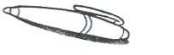
2. -------- pen.

- Read and Answer: ( / 6)
Reading:10 marks
Dear John
I am Ahmad. I can speak English very well now. I don't go to school now. I am on a holiday .We are going to make a party on Friday! I must help my mum. My dad is going to buy healthy food for the party. I am very happy in Amman. We are going to go to Aqaba in August.
Are you going to come to my Party?
Ahmad

-Answer
1. Can Ahmad speak English now? -----------------------------------------------
-Right (√) or Wrong (×):
1. Ahmad is very happy in Amman. ( )
2. Ahmad's family are going to make a party on Sunday. ( )
3. The letter is to John.( )
-Complete:
1. Ahmad is going to go to --------------------- in August.
2. Ahmad must-------------------------------------.
-Fill in with correct word from the list: ( / 4 )
beach - spices - rubbish - teeth

1. The man is selling -----------------------.
2. In Aqaba, the ------------------------- is clean
3. Brush your ----------------------------.
4. We must put -------------------------in the bin.
Writing: 10 marks

- Write ( / 1 )
Do
Does
1. ------------------- you eat sweets? 2. ----------------- she speaks English?
-Circle the correct answer: ( /6 )
1. Sami ( gets up – get up ) at seven o'clock.
2. I (have – has) lunch at half past two.
3. Are giraffes taller than lions? Yes, ( they – is ) are.
4. Is Lalia going to visit her grandparents? No, she (aren’t - isn’t)
5. Snakes are (longer - heavier) than cats.
6. We (must – mustn't) drink cola.
-Read and write the numbers: ( / 2)
- twenty:-------------- - sixteen : ---------------
- Compare and write: ( / 1)
Horses elephants
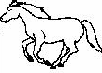
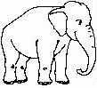
fast

Listening: 10 marks
Listen and complete:- ( / 3 )

1. He likes -----------------------
2. I have got a --------------------------.

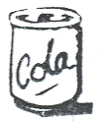
Listen and tick (√) the healthy food :- ( / 6 )
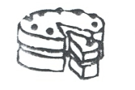
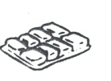
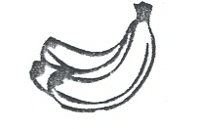

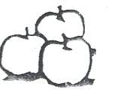
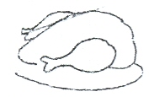
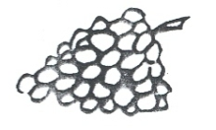

Listen and circle the odd word? ( / 1)
hear bear boy dear

