grade 2nd exam 2nd semester

Date: / 3 / 2018 Section ( ) Name:………………………………….الاسم:

1) Read and draw:

1) 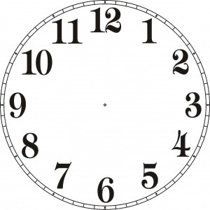 2) 3)

It's half past two. It's six o’clock. It's ten o’clock.

2) Look and Match:

fig olive cake

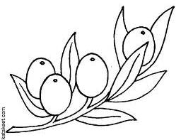
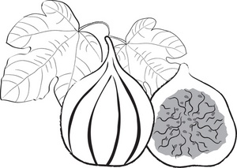
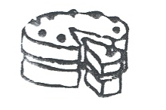

3) Match and say:

sixteen thirteen twenty twenty-one

13 16 14 21 20
4) Trace and copy:
D

d
date

W

w
watch

