
Ministry of Education
Ajyad International Schools

Scholastic years: 2018 / 2019 Second semester Grade: Ten
Date of exam: ………….., Time:…………
Student's name:………………………………. Teacher's name: Thaer Mamoun

Total(40) |  |  | 6 | 4 | 8 | 4 | 18 | Question mark
 |  |  |  |  |  |  |  | Student's mark
ــــــــــــــــــــــــــــــــــــــــــــــــــــــــــــــــــــــــــــــــــــــــــــــــــــــــــــــــــــــــــــــــــــــــــــــــــــــــــــــــــــــــــــــــــــــــــــــــــــــــــــــــــــ

First Question:- Q1) Read the text then answer the questions below: (18 points)
The polar pear lives in the cold, snowy Arctic lands in the North Pole. It has a thick layer of fat underneath its skin and this helps to keep it warm. It also has a thick layer of fur all over its body, including the sole of its feet, which allows it to swim in the coldest seas without feeling the cold. Beneath the fur the skin is black, so it absorbs heat.
Unlike polar bears, penguins live in the South Pole and many live in Antarctica. Penguins keep warm with thick skin and lots of fat under the skin. Penguins have dark colored feathers on their back, which absorb heat from the sun to keep them warm>
******************************************************************
- Where does the polar bear live? (2 points)

- What do polar bears and penguins have in common? (3 points)

- How do penguins keep warm? (2 points)

- Give the word that means (The opening of the nose) (2 points)

- Write down the sentence which indicates that penguins do not live in (3 points)
the North pole:

6) What does the pronoun (It) in line (1 ) refer to? (2 points) _________________________________________________________________________________
Name the following animals:- (4ps)
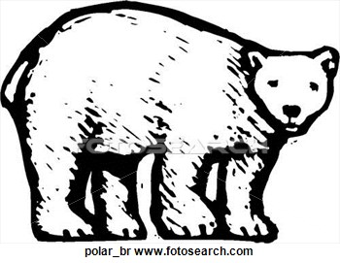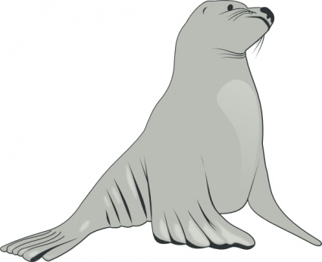



Q2) Fill in the gaps with one word from the box: (4 points )
Water proof , skis , scenery , guidebook , towel

- I’ve been here for two days and I have seen some wonderful ---------.
- If you go to England ,you should take a -------- --------- coat – It rains a lot .
- It's useful to have a ------------- when you travel in a foreign country.
- At the mountain resort, you can hire ------- and a warm jacket for a skiing holiday
________________________________________________________________________________________
Q3) Fill in the blanks correctly (8 points)

- She would ---------- (be) happier if she had (have) more friends.
- We would --------- (buy) a house if we------- (decide) to stay here.
- If she----------------- (not/be) always so late, she would------- (be) promoted.
- If we-------- (win) the lottery, we would travel ---------(travel) the world.

________________________________________________________________________________________
Q4)What would you do in the following situations? (4 points)
Write sentences using the second conditional.

- You get lost in the city,

- You found a valuable item in the street .

________________________________________________________________________________

Q5) Correct the mistakes in the following sentences . (6ps)

1. If you goes to the Poles , you would saw a lot of snow and ice.( Went , see)
………………………………………………………………………………………………………………………………………………………………………..

2. If I were you , I will helps my mother .would help
…………………………………………………………………………………………………………………………………….

3. Why don’t we did the homework? do

…………………………………………………………………………………………………………………………………………………..

