Name: Date: Unit:14 5TH grade
What Should we eat?
Aims:. To classify things according to the two headings below.
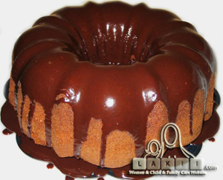

These are good for you Do not eat too much of these

Milk - sweets - biscuits - water - fruit - fizzy drink

- You should drink -----------------and-----------------------------.
- You shouldn’t eat-------------------------and---------------------.
- You shouldn’t drink---------------------.

Talk about you:-
1-I eat fruit and vegetables a- I am healthy
so

2- I am not tired b- I slept early
because

3- I shouldn’t watch a lot of TV c- I am tired
4- I do exercises

