Grade 5

Objective : To give and follow instructions.
To describe how things sound, smell,taste,delicious,feel.

.

1- Read and complete :
Example :
We are going to make mansaf:-

First ____________________.

Then____________________.

Next add _____________________

Finally____________________

2- Think and write :
- 1-Red rose------------------and------------------beautiful. 

2-Its sunny. It -------------------------hot.

3-It tastes ----------------------- . 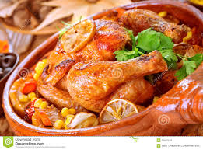

4-A foot ball mach--------------noisy 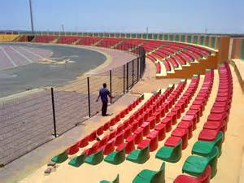

Remember !


cut First
wash

add Then

cook
Finally serve

3- Put ( grow - oranges - makes - eggs -farm )
1-I live in ---------in Jordan .
2- We -------- vegetables .
3- On my farm there are --------trees .
4- We breed chic hen and we got ---------from chicken .
5- Mum ---------- yoghurt from milk .

To be good at English , STUDY HARD .


