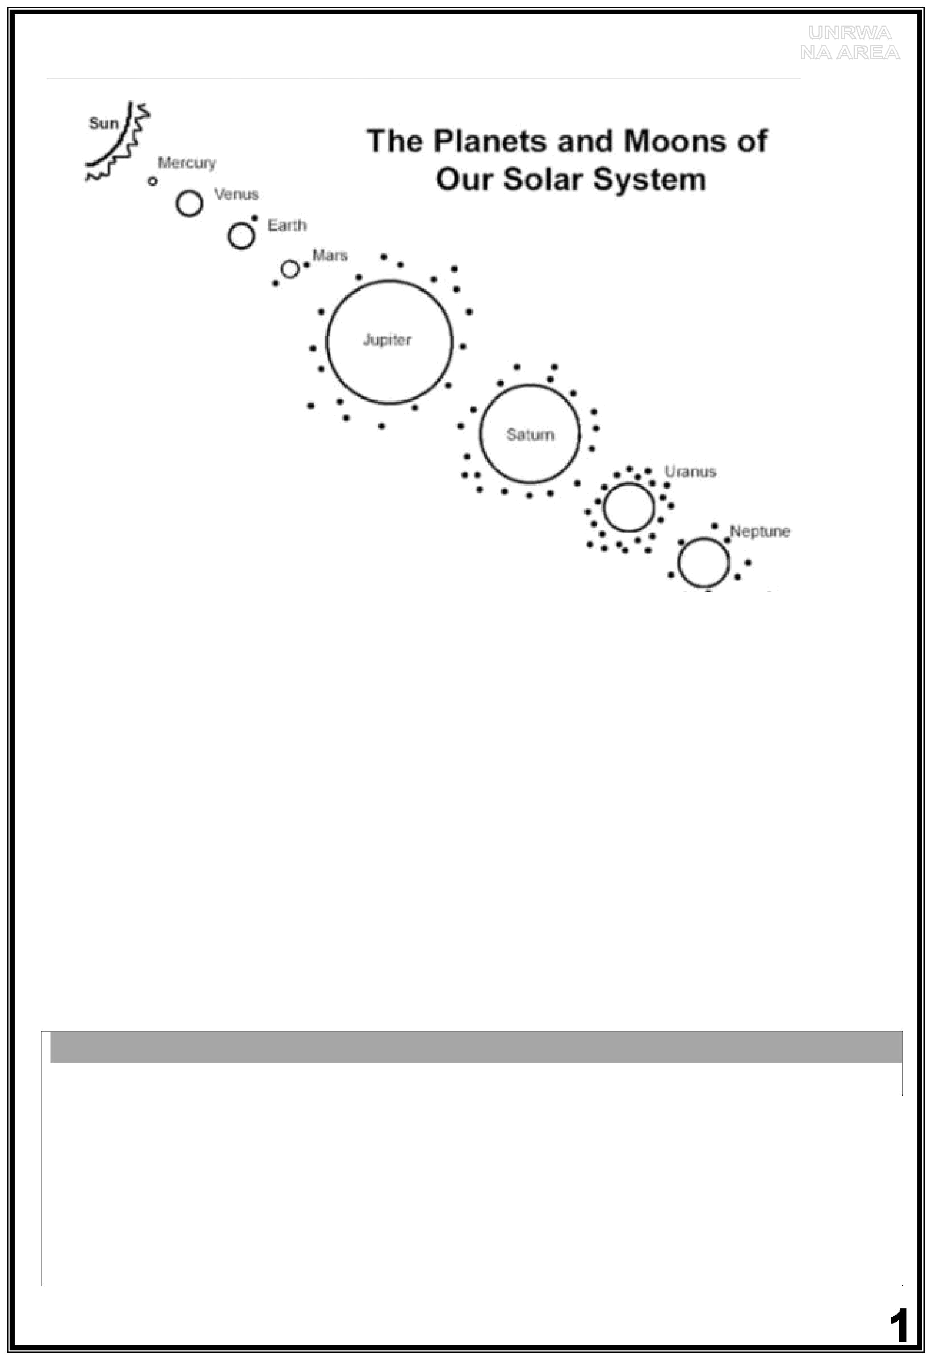
Unit Ten

a. Colour the Sun yellow. b. Colour the Earth blue.

c. Colour Mars red. d. Colour Jupiter orange.

e. Colour Saturn brown. F. Draw some stars in the sky.

************************

Look at the picture and answer the questions with short answers:

- Is the Sun a planet or a star? _________________________

- What is the nearest planet to the Sun? __________________

- Which planet do we live on? __________________________

- What is the biggest planet? __________________________

- What is the smallest planet? __________________________

- How many moons has Mars got? ________________________

- Is Mars bigger than the Earth? _______________________
***************************
Complete the table like the example:

small | smaller | the smallest
 | brighter
 |  | the coldest
big
hot
 | slower
dry

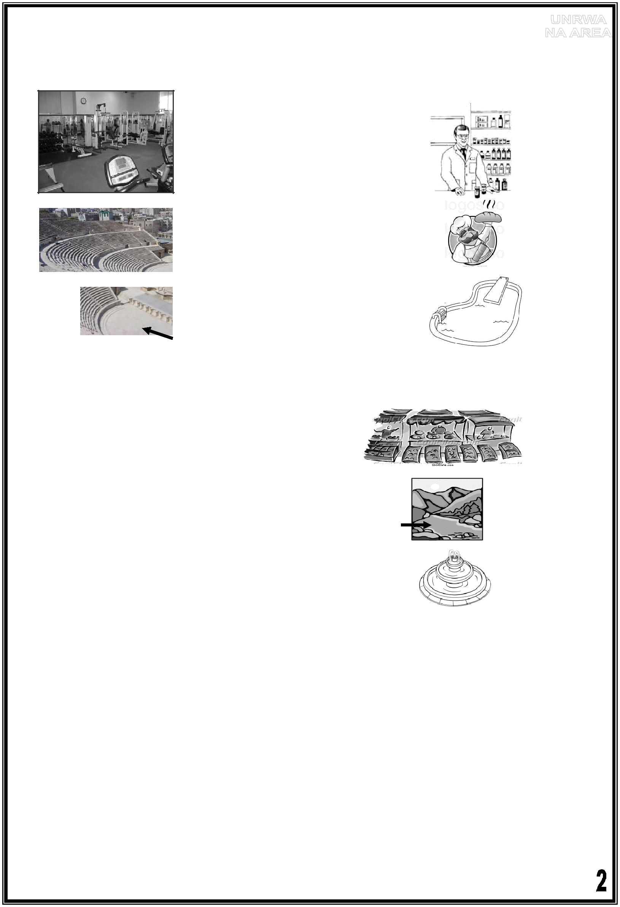
Fourth Grade
Unit Eleven
1) Match between the words and the pictures:

a pool

a stage

a sports centre

a chemist's

a baker

The Roman Theatre

****************************
- Circle the right answer.

  - Is that a market?

Yes, it is. No, it's not.

2. | Is that a river?
 | Yes, it is. | No, it's not.
3. | What is that?
 | It's a pool | It's a fountain.

- Choose the right answer:

1. In the past, the sports centre ( isn't - wasn't - aren't ) here.

- Now, this ( is – was – are) a sports centre.

- In the past, the Roman Theatre (is – was – are) bigger.

- There (is – was – were ) small trees in the garden.

- Now, the trees ( is – are – was) taller than the houses.

- In the past, there ( wasn't – weren't – isn't) computers.
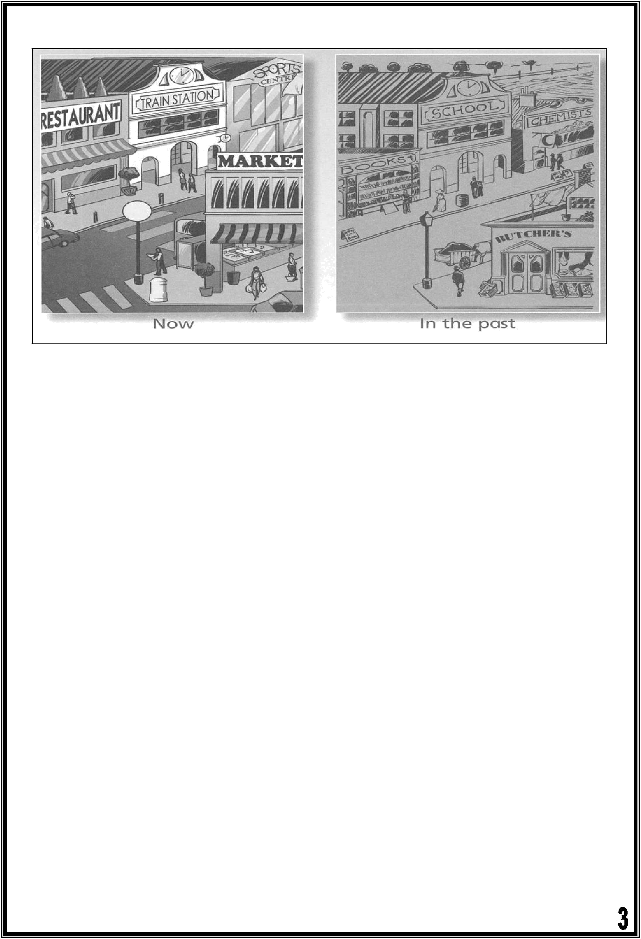
4) Look at the pictures and write:

Now, there is a restaurant.

In the past the restaurant wasn't here.

It was a ……………………..…..

Now ……………………………………………………………………………………………………………….

In the past………………………………………………………………………………………………… It was ………………………………………..

Now ……………………………………………………………………………………………………………….

In the past…………………………………………………………………………………………………………… . It was ………………………………………………………….

*************************

5) Fill in the spaces with :( is – was- were – wasn't – weren't)

- Now, there _____ a big mosque here. In the past, it ______ small.

  - This year Ali ______ ten years old. Last year, he ________ nine.

  - Yesterday, there ________ three pens on the table.

  - In the 1970s, there ________ any mobile phones.

- At the weekend, I _________ at home. I was in Wadi Rum.
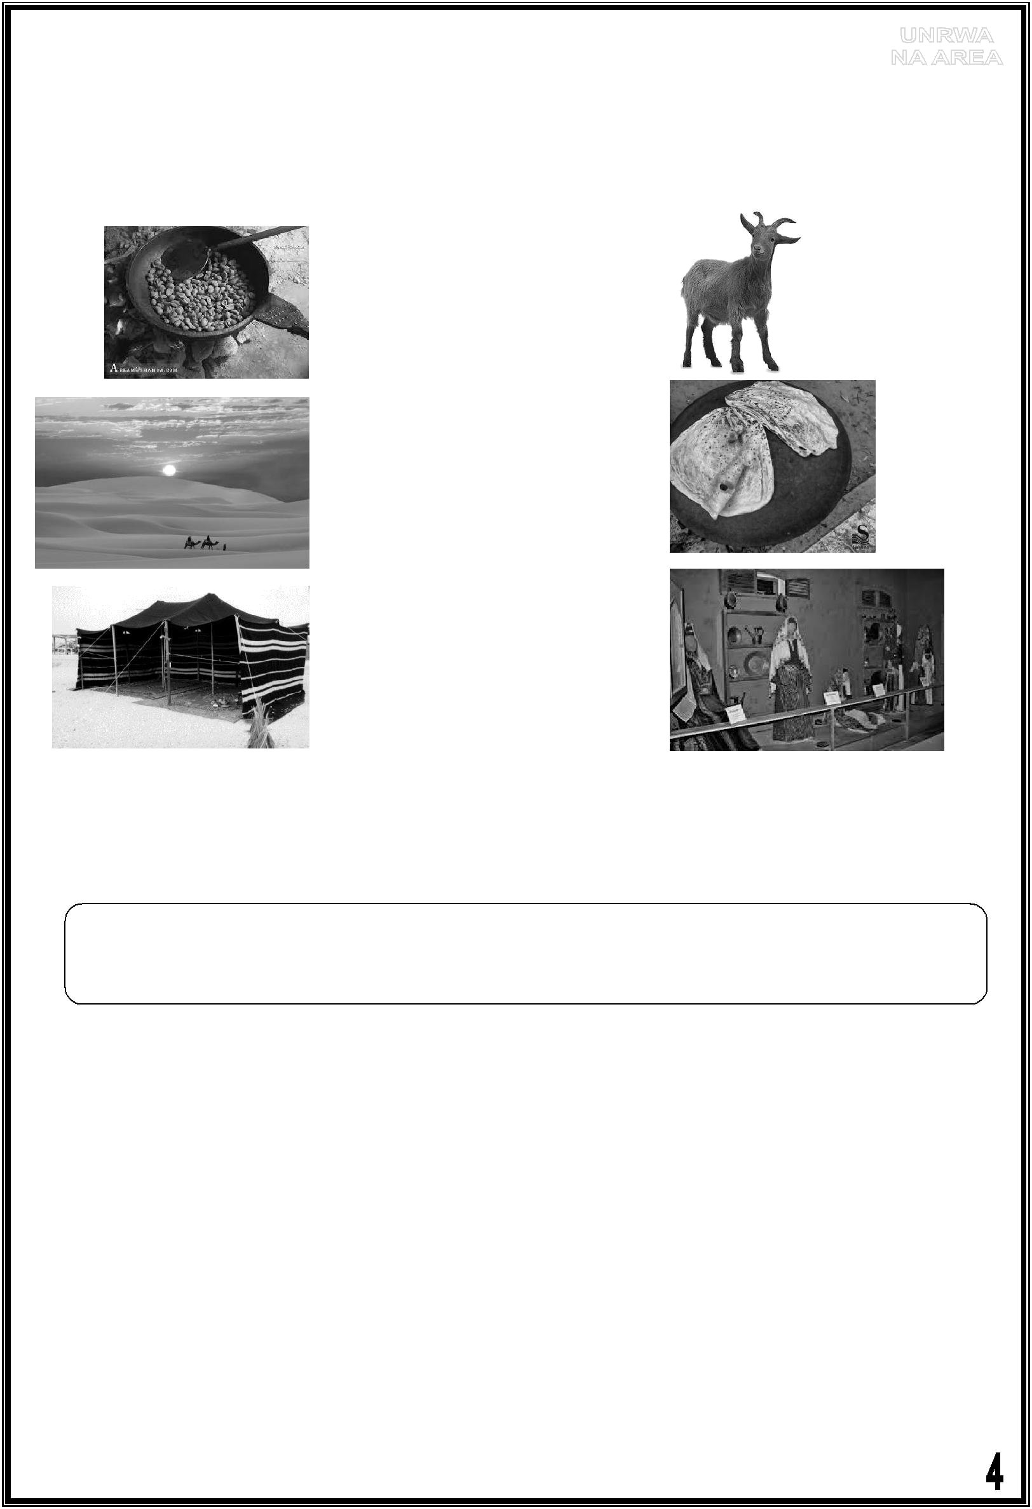
Fourth Grade
Unit Twelve

1.Match the words with the pictures:

bread a tent

a museum

coffee

a goat

  - desert

- Complete the sentences about yourself. You can choose from these verbs:

was | visited | lived played listened | cooked helped | tidied
 | bought saw | brushed cleaned wrote | drew

This morning, I ___________________________________

Yesterday, I _____________________________________

Last night, I __________________________________

Last weekend, I ____________________________________

Last month, I _____________________________________

Last year, I _____________________________________
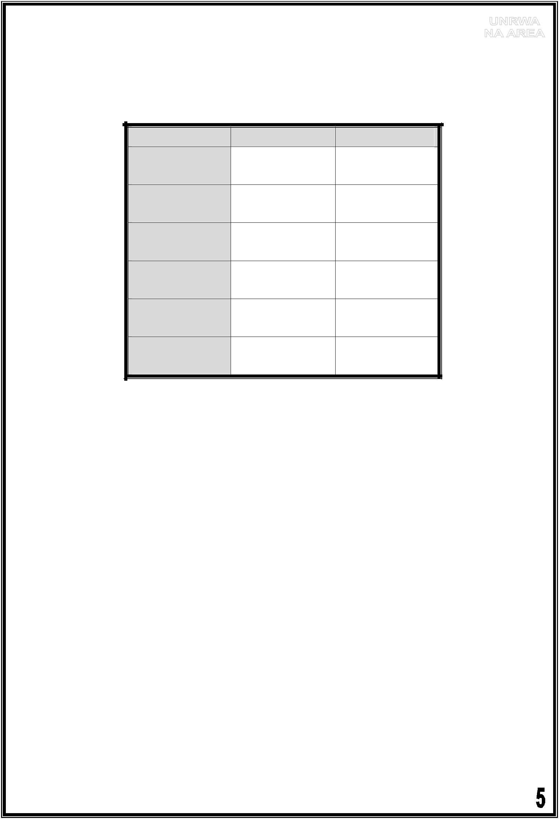
Fourth Grade
Unit Thirteen
Review

1) Look at the table below and make sentences:

 | Salma | My parents
Saturday | sports centre | home
morning | sports centre | home
Saturday | the Roman | the market
afternoon | Theatre | the market
Sunday | school | work
morning | school | work
Sunday | the old city | the
afternoon | the old city | restaurant
Monday | school | work
morning | school | work
Monday | museum | library
afternoon | museum | library

  - On Saturday morning, Salma was at ______________.

  - On Saturday morning, my parents were at _____________ .

  - On Sunday _______________________________________________.

  - On _____________________________________________________.

  - _______________________________________________________.

  - _______________________________________________________.

- Look at the table below and compare between the boys:

 |  |  | Rami |  |  | Faisal |  |  | Ayman
 | Age | 11 |  |  | 12 |  |  | 13
 | Height |  | 1.5 m |  |  | 1.55 m |  |  | 1.53 m
 | Weight |  | 45 kg |  |  | 47 kg |  |  | 50 kg

Faisal is older than Rami. (old)
- Ayman is the __________________ boy. (old)
- Faisal is the __________________ boy. (tall)
- Ayman is the __________________ boy. (heavy)

- Faisal is ____________________ Rami. (tall)
- Rami is _____________________ Faisal. (young)
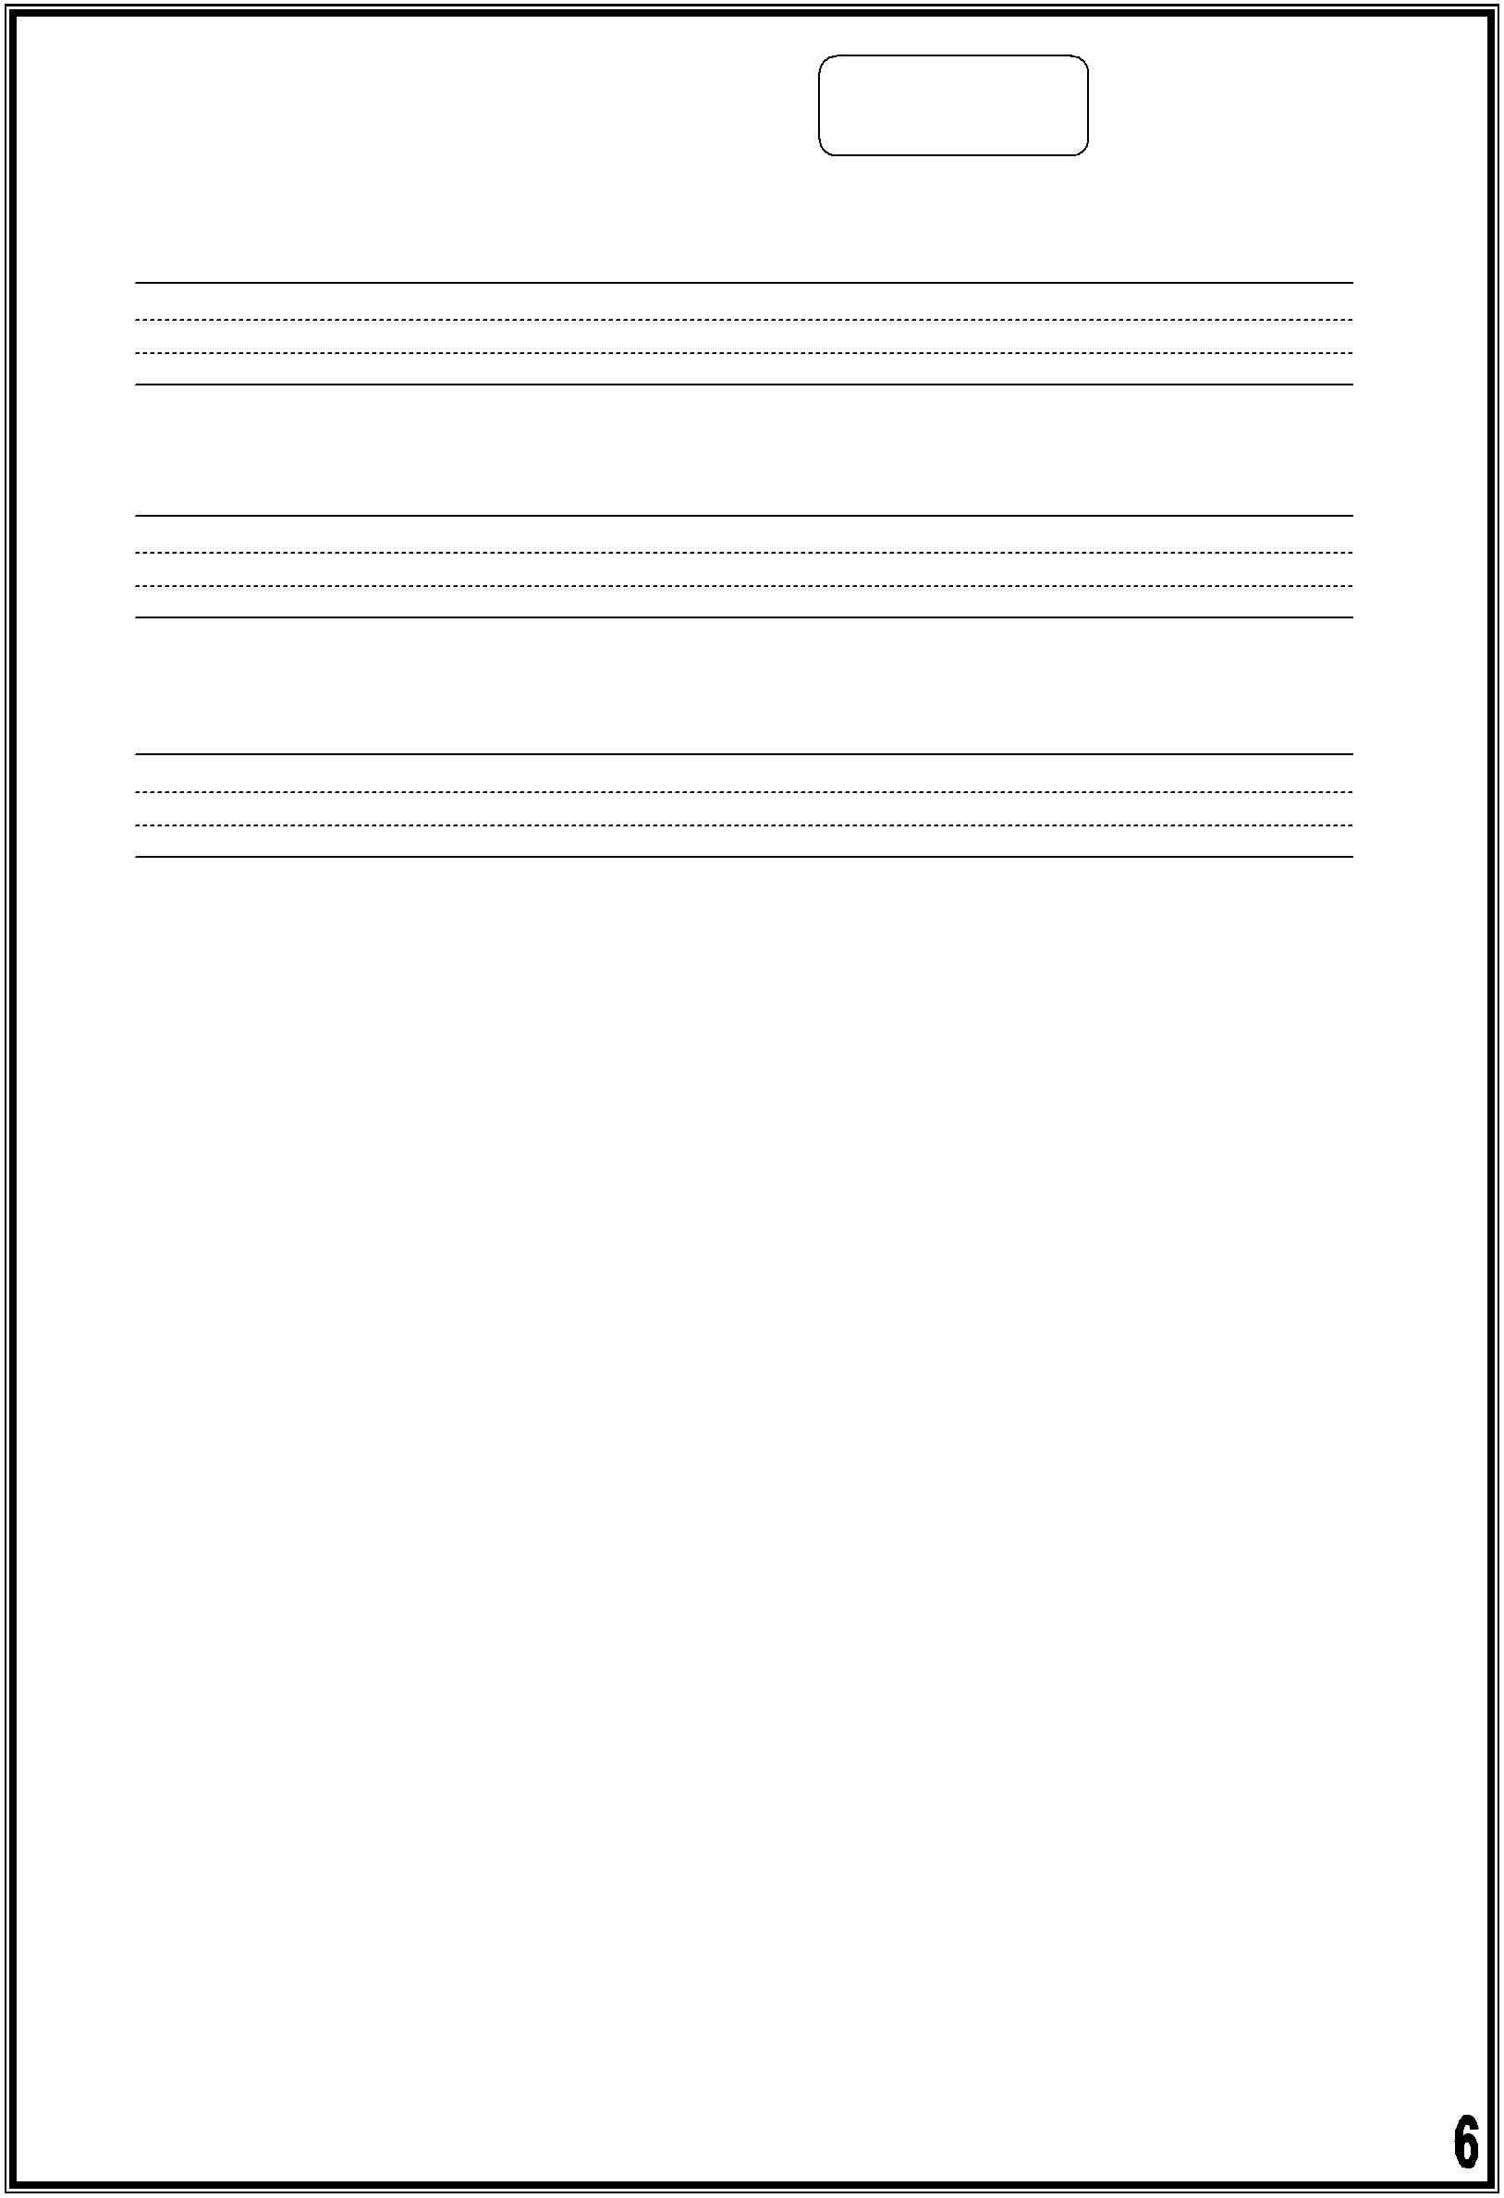
3) Copy and complete the punctuation: , . ?

- In the past there was a small park opposite our house

- Was there a hotel in the old city

- No there wasn't

4) Read and answer the questions:

In the past, there were nine planets in the solar system. Now, there are eight planets. Pluto is not a planet now. It is a dwarf planet. It is very small, but it has five moons. Pluto is very far away from the Sun; so, it is very dark and cold.

1. Read and circle Yes or No

A. Pluto is a star. ( Yes / No )

    - Pluto is cold because it is far away from the Sun. ( Yes / No )

- How many moons does Pluto have?

_________________________________________

- How many planets are there in the solar system now?

_________________________________________

- Circle the best answer:

    - "Dwarf" means: ( big - small - dark )

B. The opposite of "hot" is ( dark - light - cold )
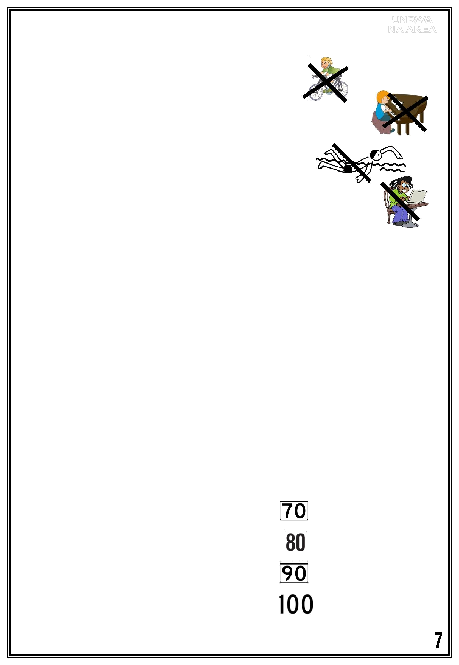
Fourth Grade
Unit Fourteen

1) Make sentences like the example:

When I was five years old, I didn't ride a bicycle.

1. When I was five years old, ____________________________

- When ______________________________________ 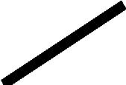

- __________________________________________________

2) Look at the table, and make sentences like the example:

 |  |  |  | play tennis |  |  | play football |  |  | watch TV |  |  | use the computer
 | Ali |  |  | ✓ |  |  | X
 | Layla |  |  |  |  |  |  |  |  | x |  |  | ✓
 | Ahmad |  |  | x |  |  | ✓
 | My parents |  |  |  |  |  |  |  |  | ✓ |  |  | x

Ali didn't play football yesterday. He played tennis.

- Layla __________________________________________________.

- Ahmad _________________________________________________.

- My parents ______________________________________________.

3) Circle the right asnwer:
1. ( seven - seventeen - seventy )

2. ( eighty - eight - eighteen )

3. ( nineteen - ninety - nine )

4. ( ten - a hundred - one )
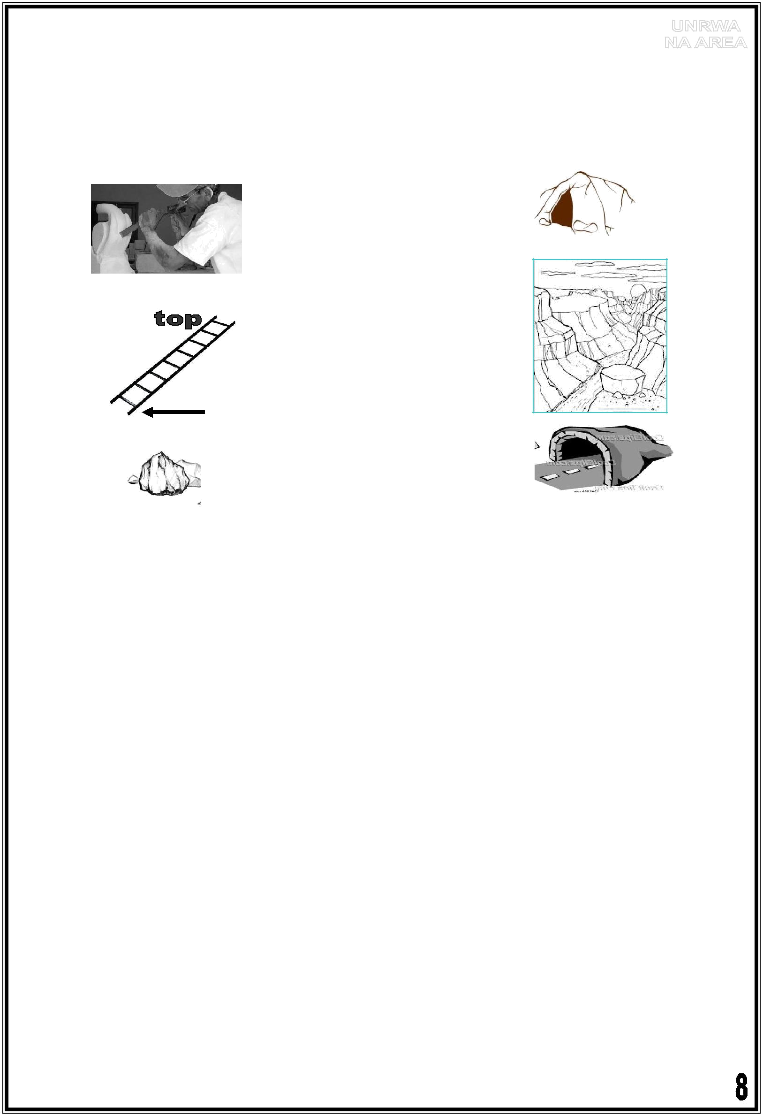
Fourth Grade
Unit Fifteen

1) Match the words with the pictures:

a canyon carve

a tunnel a rock a cave bottom

2) Circle the best question word:

1. ( When - Where - Who ) did you stay? At a hotel.

2. ( Who - Where - What ) did you do yesterday? I visited my aunt.

3. ( How - Who - What ) did you go to school? By bus.

  - ( When – What – Who ) did you arrive? At seven o'clock.

- Rearrange the words to make questions:
  - you - Where - go? - did
_______________________________________

  - travel? How - you - did
_______________________________________

3. you - What - about? - did - learn

_______________________________________
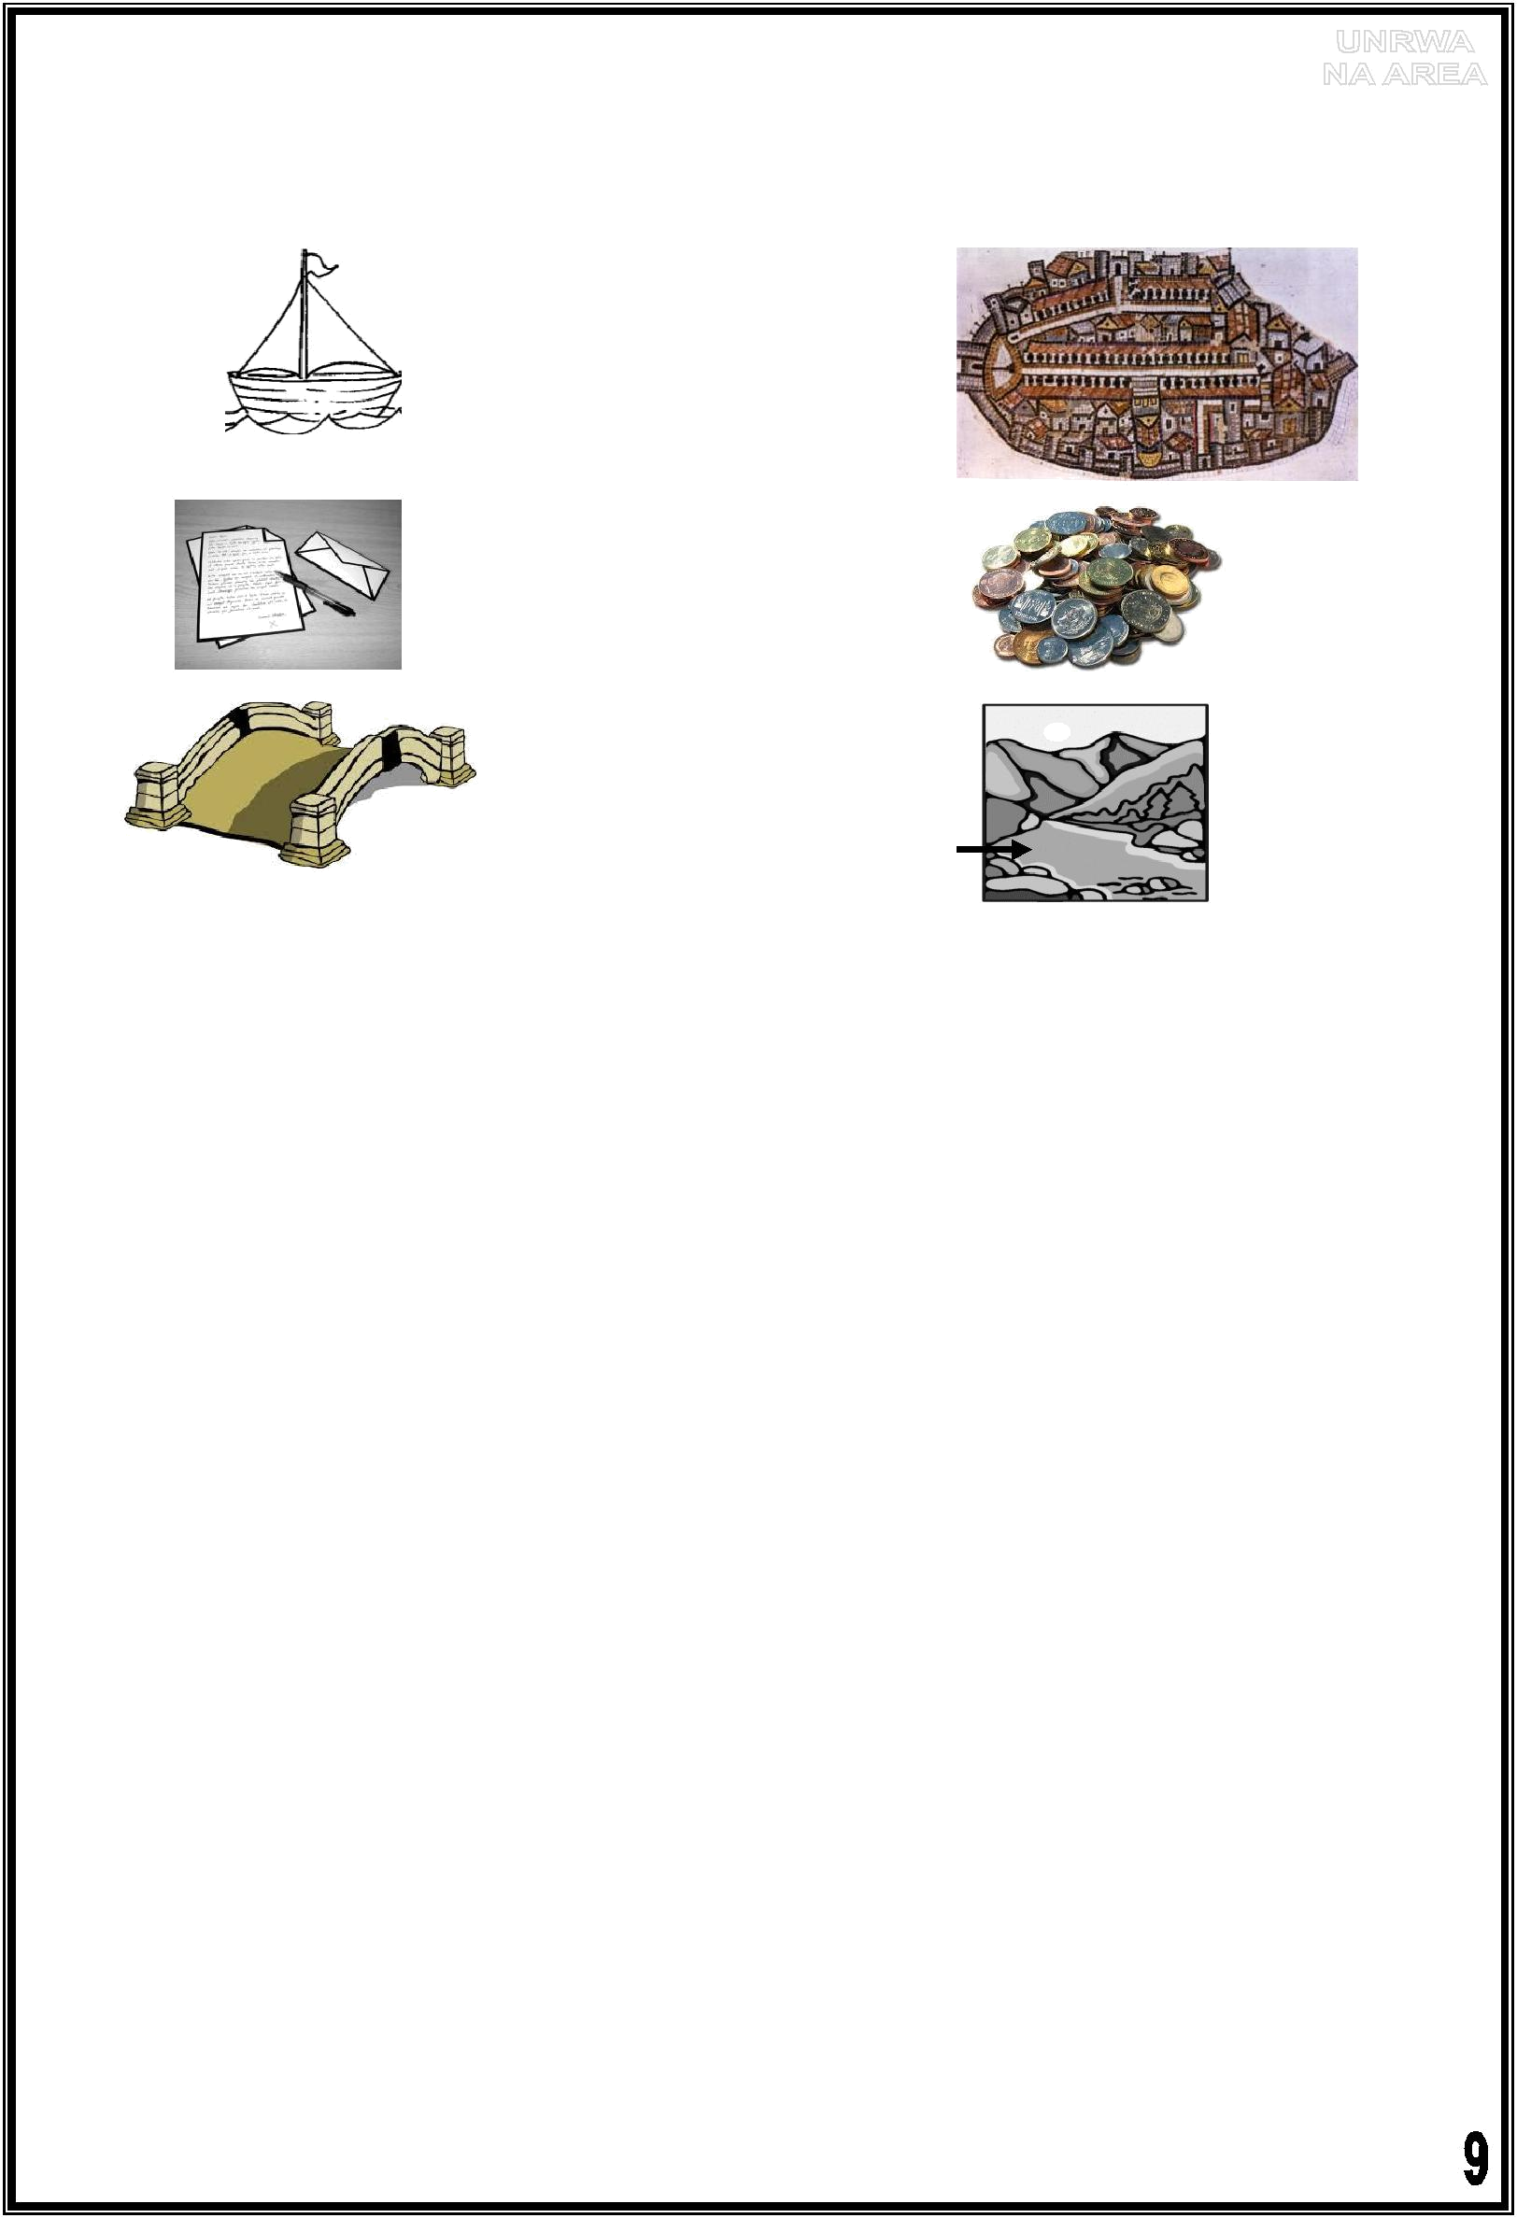
Fourth Grade
Unit Sixteen
- Match the words with the pictures:

a letter

a boat

a river

a bridge

mosaics

coins

2) Complete the table:

Present | Past
I drive to work every day. | I ___________ to work yesterday.
I have breakfast at six o'clock every day. | I ________ breakfast at seven o'clock
 | yesterday.
I go to school by car. | I _______ to school by bus last week.
I see birds every day. | I _______ a lion in the zoo last year.
I sometimes find pencils under my desk. | I _________ a coin in the park last week.
I buy a sandwich every day. | I ___________ a sandwich yesterday.

3) Make sentences about yourself. You can use the following verbs:

went - drove - saw - found – spoke – wrote - read - sent - bought – had Yesterday, I ________________________________________

Last night, I ________________________________________

Last weekend, I ______________________________________

Last month, I ________________________________________

Last year, I _________________________________________
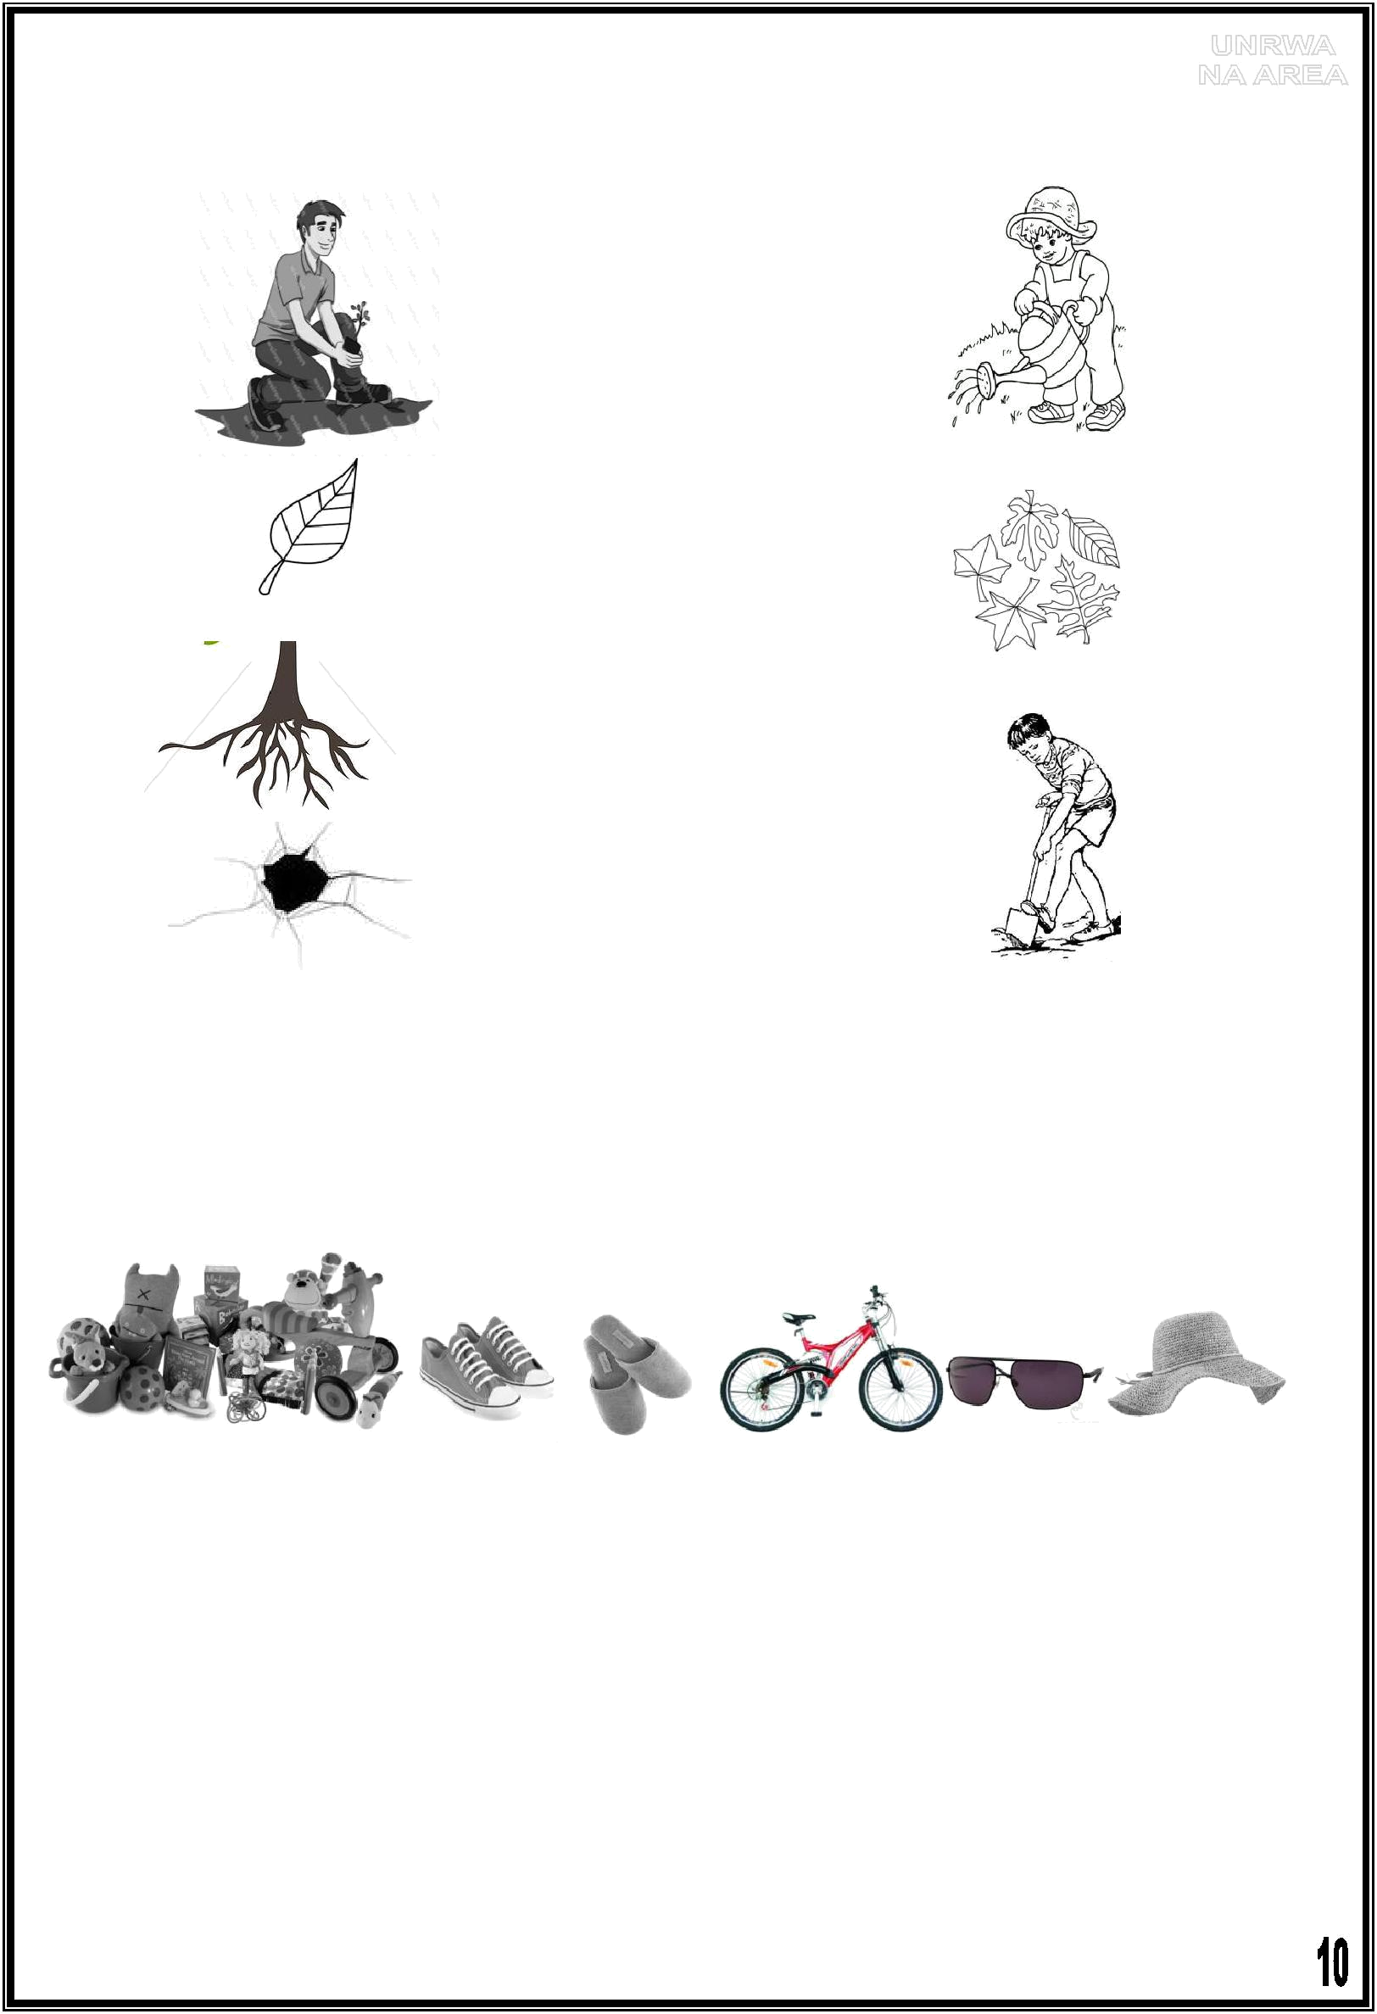
Fourth Grade
Unit Seventeen
- Match the words with the pictures:

a leaf

leaves

dig

plant

a hole

water

roots

**************************************************

- Look at the pictures and answer the following questions: a. Write the names below the pictures:

sunglasses - slippers - toys - trainers - a sun hat – a bicycle

___________ _______ _______ _________ ________ _________

b. We are going to Petra next weekend. Circle three things we must take with us:

- We must take ________________________________ .
- We must ___________________________________ .
- We ________________________________________ .

- We don't have to take _________________________ .
- We don't ___________________________________ .

- We ________________________________________ .
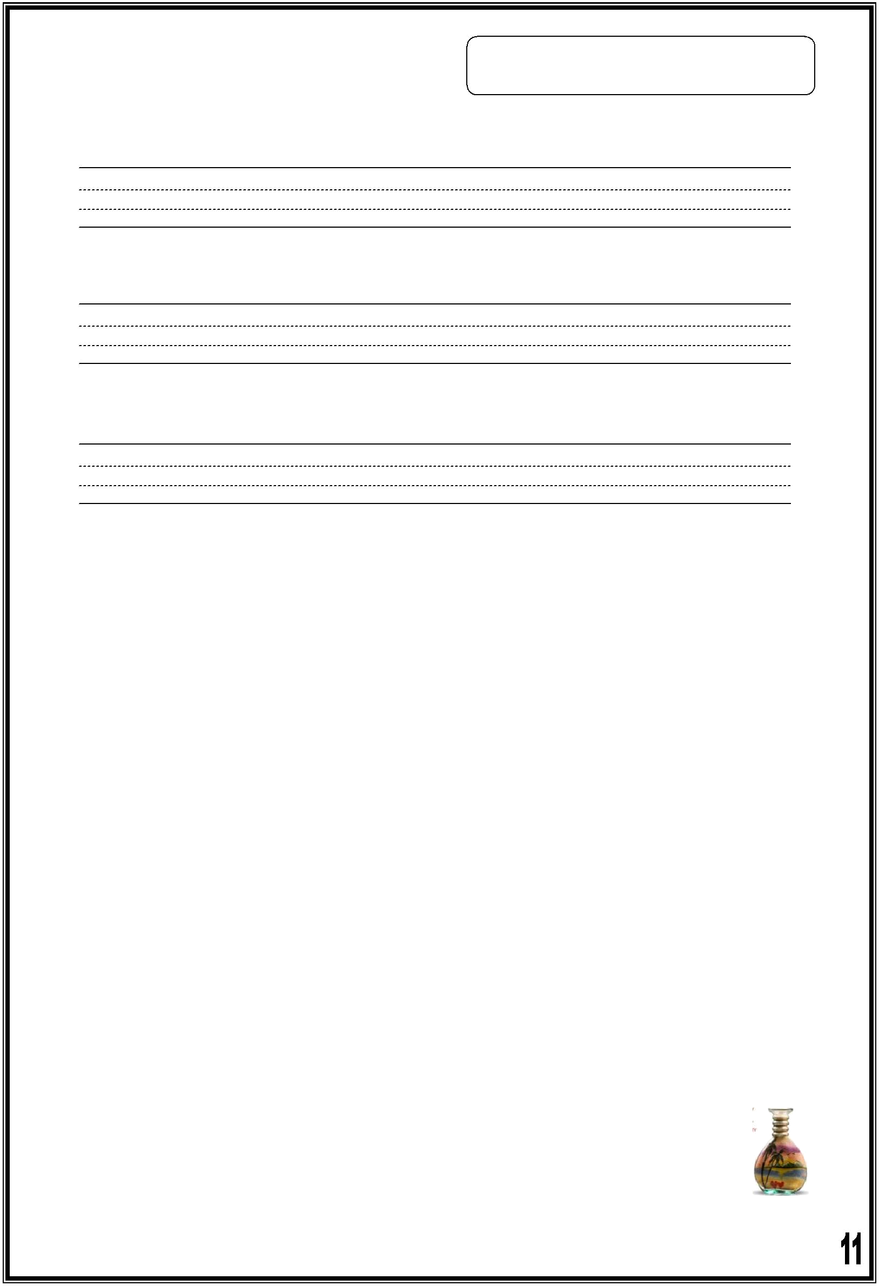
3) Copy and complete the punctuation: , . ? Capital letters

- was there a school here

- no there wasn't

- yes jupiter is the biggest planet

**************************************************

4) Read and answer the questions:

Salma and her family drove to Aqaba at the weekend. They swam in the sea and sat on the beach. Salma took some photos and her mother bought a colourful sand bottle and some postcards. The family had dinner at a restaurant. They enjoyed their trip a lot!

1. Read and circle Yes or No

A. Salma went to Aqaba with her friend. ( Yes / No )

  - The trip was nice. ( Yes / No )

- Where did they sit?

_________________________________________

- Who took some photos?
_________________________________________

- Circle the best answer:
  - The verb "had" means: ( ate - drank - saw )

B. Which one is a sand bottle? ( -   

