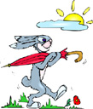
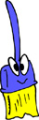
Alphabet letters

Match the capitals to the smalls:

F h
G i
H f
I j
J g

Alphabet letters

Match the picture with the first letter of its word:

f
g
h
i
j

