The Ministry of Education

25
The Education Directorate of /
……………………… School
Final Exam- First Term
Class: First Grade Material: English Language
(Action Pack 1)
Date: ….\1\2018
Time: One hour.

Name: ....................................................................................................Section ( )

Q1 Fill in the blanks:-( 4 marks )
sister - Hello - red - Dad
1- It's a ____________an apple.


2- This is my ____________ .

I'm Sami.

3- ___________! I'm Sami .

4- Dana is my ___________.
I'm Dana.

Q2 Write the correct colour under each picture:-(3 marks)
yellow

red

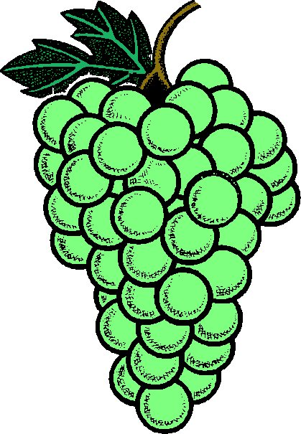
green

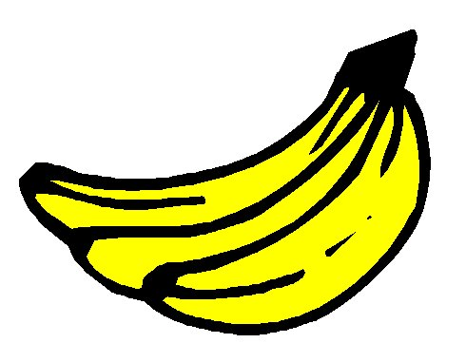
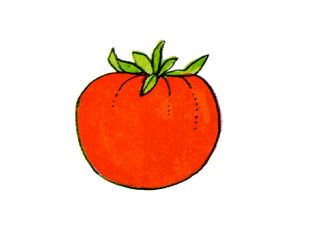

----------------------------- --------------------------- ---------------------------------

*********************************************************************

Q3 Write the missing letters :-( 3 marks )

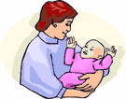

____ rother M___m

Q4 Choose and circle the missing letters :-( 3 marks
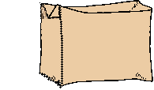
1) bo____ ( s - x )

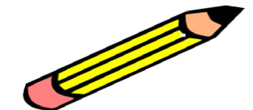
2) pe___( n - m )
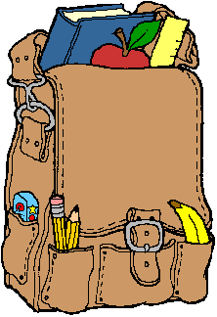

3) ba __ ( g- j )
Q5 Circle words that don't have the same rhyme:-( 3 marks)

lap - ball - hat - bat


man - bag - dog - fan


cat - tack - jack - back
*************************************************************
Q6 Match then write the numbers:-( 6 marks )
How are you? you you

1- Oh! Thank you !
I'm fine, thank you.
Hello!
2-

Hello!
This is for YOU

3-
Q7 Copy the following word on lines correctly:-( 3marks)

Blue

T

THE END WITH MY BEST WISHES

