First English Exam for Fourth Grade
First semester 2017
Name:……………………………………… Class:……………………
Mark: _____/ 20 Mark: _____/ 10

Q1: Read the text then answer the following questions. (5 m)

Anas and Abdulrahman live in Amman. It's a big city. Our house is near the mosque. We go to the mosque to pray. We always visit the Roman Theatre with our parents at the weekend. We go shopping in the market.

1) Anas and Abdulrahman live in Ajloun. (T / F)

2) Amman is a big city. (T / F)

3) They don't visit the Roman Theatre. (T / F)

4) They pray in the ____________________ (mosque / school)

5) They go shopping in the ______________ (cinema / market)

Q2: Match between sports and pictures. (4 m)
Football | Basketball | Cycling | Running

  .................. |   …………………… | 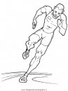  ……………………………. | 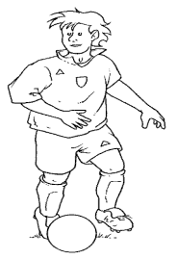  .............................

Q3: Change numbers into words and words into numbers. (4 m)

10) 20 …... ……………………………………………………………………………

11) 22 ……………..…..………………………………………………………………

12) twenty seven ………………………………………………………………………

13) twenty nine …………………………………………………………………….

Q4: Put the correct time under each picture using words from the box. (2 m)
It's quarter to seven | It's half past ten

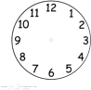
14) ____________________ 15) ______________________

Q5: Complete the following using words from the box: (5 m)
is | who | are | what | I

16) _________________________ is this? This is my friend Ibrahim.

17) ________________________ are you doing Ghalib? I'm studying.

18) Luay and Yassin _____________________ good students.

19) __________________________ like to watch T.V.

20) My name ______________________ Muhammad.

