The Second Exam For The Second Semester
9th Grade ( ) Date and Day: Monday16/ 4 / 2018
Name: ………

Question Number One :
Read the following text and then answer the questions: ( 12 points )
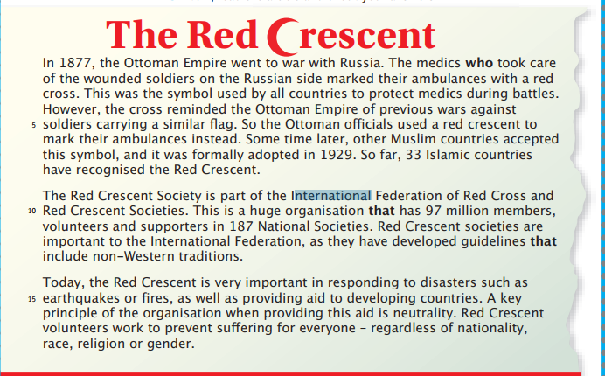
- Why does the Red Crescent used in battel ?...................................................................................................
- Write down the sentence which Indicates that the symbol of the Red Crescent is adopted in the Islamic countries.…………………………………………………………………………………………………………………………………..
- The underlined pronoun their line ( 6 ) refer to ……………..
- Give one example for the following :
- Relative pronoun ( refer to person )…………………..
- Linking word …………………….
- The opposite of generous ………..
- Synonym or big ……………….
- What are the importance of the Red Crescent today?
Question Number Two(9 points)
A: Fill in blanks with one of the following words: ( 5 points)

bankrupt / bring /trust/ sensible /borrow /possessions
  - …………………… is thing belonging to a person .
  - Mr Lin didn’t …………………. In bank
  - Nadia took a ……………………… decision not to eat ice cream until she feels better .
  - When economic collapse, many businesspeople lose all their money and become ……………..
  - Samir , may I …………………………… this pencil from you ?

B: Correct the mistakes in the following sentences: (6 points )
- There were a few people in concert , so the hall was full .
- I didn’t read many information in this book .

Question Number Three(7 points)
A: Circle the correct answer. (5 points))
1.Mr.lin wanted to have ………..money .
a. A lot of b. little c. a few
2.There aren’t ………………… trees in the garden.
a. much b many c. a lot of
3.She hasn’t got ………………. friends.
a. much b. some c. any
4.Don’t waste ………………… time watching TV.
a. much b. some c. many
5.I haven’t read ………………… books.
a. afew b. many c.much

B: Use How much and How many to complete these questions.(4 marks)
1. …... books a month (read)?............................................................................................................
2. ……………………..gold you (buy) last week?.....................................................................................................

Question Number Five(8 points)
A:Guided Writing (4 points)

Read the information below, and write two sentences about the Tips on how to do well in school.
Tips on how to do well in school.
- Do all of your assigned homework.
- Sleep and wake up early.
- Study carefully in details.

B : Editing :(4 points)
Find eight mistakes in the following text ( 3 grammar mistakes / 2 spelling /3 punctuation ) and correct them.
mr Lin were a really hard working man.every day , he worked for ten or twelve hours but he sleep for just a little , Mr. Lin had one purpose in his mind. He is a misre man. His wife was sufring in her life .

1 ……………….. 2 ……………………3……………………….4………………5…………
6……………………..7…………………..8…….....................
Good Luck
T. Aisheh Al-Naimat

