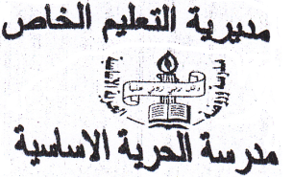
ـــــــــــــــــــــــــــــــــــــــــــــــــــ
Private Education
Al-horiya School
Second Exam
First Grade
Name: ...................................

Reading:-(5 marks)
Read and order:-

1- bus. / It's / a blue
.........................................

2- this / I / shirt. / like
.....................................................

3- three car. / are / There
......................................................................

4- many / How / there? / are
.........................................................

5- a green / It's / bike.
...........................................

Writing:- (5 marks)

2- Write the suitable word beside the following picture:-(3)

hop | jacket | four

1-I like this ………………
2-There are …………… cars.
3-I can ………………

2-Write correctly:-(2 marks)

Look ! It's a green bike.

Speaking:-(7.5 marks)

1-Complete the numbers:-(6 marks)

0ne..........three...........five.............

2-Read and match:-(1.5 marks)

seven 4
four 7
ten 10

Listening:-(7.5 marks)
1-Listen and draw:-(6 marks)

2-Listen and write:-(1.5 marks)

.....................................................

