Second Exam for 5th grade The
Subject: English Second Semester Date: / /
Student's name ---------------------------
Reading Comprehension : Read the passage and answer the questions. (4 marks)
HOW TO STAY HEALTHY!
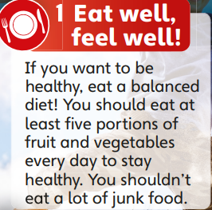
1- What kind of food should you eat to be healthy?
---------------------------------------------------------------------
2-How many portions of fruits and vegetables should you eat daily?
------------------------------------------------------------------------------------------------------------------------
3-What kind of food shouldn’t you eat a lot of?
------------------------------------------------------------------------------------------------------------------------
4-Extract:1- noun:………………………..2-adjective……………………………
Vocabulary: Complete the following sentences using the suitable word ( 6 mark )
dizzy | desert | sleep 9-10 hours | hospital | out and about | called

1-You should ---------------------------------- each night.
2-Laila feels --------------------------so she shouldn't play football.
3-Ali feels sick so he should go to ---------------------------------
4- A hot dry place with a lot of sand is called a ------------------------
5- A big hill is--------------------- a mountain.
6- I was ill last week, so I couldn’t get------------------------------

Grammar : Choose the correct answer ( 4 Marks)
1- My head hurts. I’ve got a ----------------------
a-toothache b-earache c- headache
2-He went to the supermarket …….. fruit
a-to buy b- buy c- buying
3--I should -------------------my medicine.
a-take b- taking c takes
4-I………………go to school when I feel dizzy.
a- Should b- shouldn’t

Writing:
A:Complete the table with opposites )6 Marks)
Irresponsible / fit / irresistible / regular / healthy /unbalanced


