20

The Hashemite Kingdom of Jordan
Ministry of education \ Bani Obeid Educational Directorate
AL-Khansa ‘Mixed Elementary School For Syrian student
First semester final exam scholastic year 2025\2026
Class : 4 grade Time: 1 hour
Name : ……………….……… Day \ Date:….…………..…
أجيبي عن الاسئلة وعددها ( 3 ) وعدد الصفحات ( 2 )
Q.1 Read the text then answer the questions below : ( 8 marks )
Jawad and his dad Laith live in Amman, Jordan . they are walking in the desert near Petra ( the pink city ),it’s the most exciting place in Jordan .There is no wind and it’s very hot .His dad falls over and his leg is hurt . Jawad can’t carry his dad because he's very big . Jawad is scared, but he remembers his whistle. He blows six times as an emergency signal . soon the helicopter comes. They help them and take them to the hospital .In the end, his dad is safe .

Q.1 Where do Jawad and his dad live ?
………………………………………………………………………………………………………………………….
Q.2 What is the most exciting place in Jordan ?
…………………………………………………………………………………………………………………………..
Q.3 Why can't Jawad carry his dad ?
…………………………………………………………………………………………………………………………..
Q.4 How many times does Jawad blow the whistle ?
…………………………………………………………………………………………………………………………..
Q.2 Find from the text :
Noun………………………………… verb …………………………….
Adjective …………………………. Preposition …………..……………
Q.2 Circle the correct answer : ( 7 marks )
1- Salt is ……………………………… than suger . ( sweet )
a- sweetest b- sweeter
2- Sara is the ………………………… girl in the class . ( tall )
a- tallest b- most tall
3- Climbing is ……………………………. than swimming . ( difficult )
a- more difficult b- most difficult
4- walking is the ………………………… sport in the world ( boring )
a- more boring b- most boring
5- She ……………………………. today .
a- is swimming b- are swims
6- They ……………………………… tennis now .
a- is play b- are playing
7- Are you having lunch ?
a- Yes, I am b- yes, you are
Q.3 Match pictures with their words from the box : ( 5 marks )
Fish | camel | doctor | chef | olives

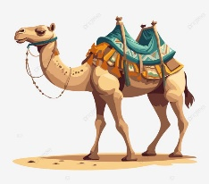
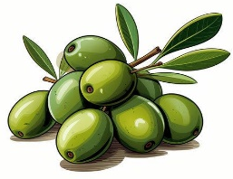
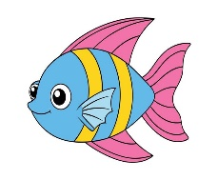
1- 2- 3- 4-


………………………… ..….………………… ……………………… ………………………
5-

……………………………. Teacher : Mariam Ghozlan

