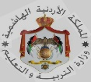
Ministry of Education / Al-yarmouk secondary school /
Qasabat Amman Directorate Syrain Center
Second Semester The final exam for English
Time : One hour For the year 2025/2026 The date:
Reading | Writing | Listening | Speaking | V&P | Total
5 | 5 | 6 | 6 | 3 | 25
Student’s name: Second grade The day:
_____________________________________________________________________________
Q1: Read the text and answer the following questions: - (5 m )
My name is Zaina. I like Teacher’s Day at school. Teacher’s day is on 5th October. We say “Thank you “ to our teacher .

1_What is the name of the girl ? ……………………..………….…………………
2_ When is Teacher‘s Day ? ………………………………………………
3_ Circle : - We say to our teacher in Teacher’s Day :
A- Thank you B- Please
4_ find out from the text :
A_ Noun : ………….……….. B_ Verb : ….................
__________________________________________________________________________________________
Q2 A: Fill in the blanks with the suitable word : ( 5 m)
[• Monster • Flag • Grandad • Bend • Bottles • Mum ]
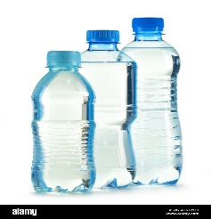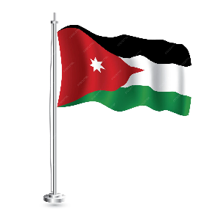

1 ………………..………… 2 ………………………… 3…..……………………… 4………………………………. 5 …………….…………..
Q3: Choose the correct answer : ( 4 m)
1_ “ Tree day “ is on :
A_ 22nd - April B_ 22nd - May C_ 23rd - April
_____________________________________________________________________________
2_ I have got ………………… fingers .
A_ nine B_ ten C_ eight
_____________________________________________________________________________

3_ Who’s this ? It's my …………………..
A_ granny B_ grandad C_ uncle
_____________________________________________________________________________
4 _Is it a dog ? yes ,it ……………..
A_ is B_ isn’t C_ are
__________________________________________________________________________________________
Q4: Write the missing letters : (4 m )
[ sh _ ar _ ee _ th _ ph ]

- Mou……….. 2_………. ms 3- kn……….s 4- bro……….er

Q5 : Copy the Sentence :
I have got two hands

( GOOD LUCK ) T. Nadia Naser

