Ministry of Education Ali Reda Alrekabi School
First English Exam First Semester (2025/2026) Class: 9th Grade
Class: Ninth Grade Date: 40
Name: Class: ( A , C)

Question 1: Read the following text then answer the questions: ( 12 Marks)
Two women are sitting in a café together .They are drinking coffee and sharing a piece of chocolate cake. The first woman seems sad a starts crying and the other woman hands her companion a tissue. Good friends share the same background, opinion interests, personality and physical appearance.

Good friends are hard to find. It’s true you can make lots of contacts on social media but you can’t be open with and rely on them, Because they may be a fake identity. Studies show that true friendships survive even when friends are in different countries. But only if you keep in touch. If you don’t, friendships can die.

Real friends stay with you and help you when you need them. They never let you down or turn their back on you.

- Where are two women sitting?
…………………………………………………………………………………………………………
- Why what do studies show?
…………………………………………………………………………………………………………
- What does the first woman give to her companion?
………………………………………………………………………………………………………….
- Why you can’t depend on contacts on social media? …………………………………………………………………………………………………………
- Find a word that means: (a piece of paper or cloth using for cleaning) ………………………..
- What does the underlined pronoun (them) refer to? ………………………………………………
Read and complete the definitions. expert gentle perfect stunning terrific
1. A hill that is not steep is ……………………………….
2. Something that is extremely beautiful or attractive is…………………………….. .
3. Something that people say is excellent or wonderful is………………………………………. .
4. Something that is done with special skills and information is …………………………………..
5. Something that is made with no problems or mistakes is………………………………………….
Question Two (Vocabulary):
A: Complete the sentences with the pronouns from the box. (7 Marks)
brother-in-law | only child | Second cousin | sibling | twins | widow | widower

1: Faisal is seventy-five. His wife, Abeer, died last year. He’s a ……………………
2: Husam married my sister last year. I really like him. He’s my …………………….
3: Aisha is eighty-five. Her husband, Abbas, died last year. She’s a ………………….
4: Amal has no brothers or sisters. She is a/an ………………….
5: Fadia is my cousin. She has just had a baby, Jaber. He is my …………………
6: Abeer is 14. Her brother is 11 and her sister is 9. She’s the oldest ………………
7: Hani and Maher are brothers. They were born on the same day, but Adel is half an hour older than Maher. They’re…………………………

B: Complete the sentences with the pronouns from the box. ( 6 Marks)
Anyone Anything Anywhere Everyone Nothing Somebody Something

- I can’t find my phone ………………….
- ………………loves Asma. She’s really nice.
- I’m looking for ………………to give to Mum on her birthday but I can’t find!
- Does……………… want to go with me to the match tonight?
- I’m really bored. I’ve got……………… to do.
- ………………phoned you a few minutes ago
C: Choose the correct words to complete the sentences word. ( 6 Marks)

- 1-I haven’t got ________ to say to you.
A-nothing B-something C-anything
- Is there ________ else you’d like to visit while you are here?
A-anywhere B-everywhere C-nowhere
- We’re bored. There’s ________ to do here.
A-anything B-something C-nothing
- I want to go ________ exciting next year, like India.
A-anywhere B-somewhere C-everywhere
- 5 Do you know ________ here?
A-somebody B-nobody C-anybody
- 6 Listen, ________. I have something important to tell you.
A-everyone B-someone C-anyone
D: Complete the sentences with reflexive ( 8 Marks)
Ourselves – Itself – Himself – Yourselves – Myself – Himself – Themselves - Herself

- Our dad is working late today, so we’re making dinner by ______________.
- The computer will switch ______________ off after about ten minutes
- 3 That funny noise is my brother singing to _____________ in the shower!
- There are three of you. You can tidy the house by __________.
- I don’t like being in the house at night by __________.
- Habib bought__________ a new suit for the wedding.
- This is a great game. You can see that the children are enjoying __________!
- My grandmother lives by __________, but she’s got lots of friends so she isn’t lonely.

Answers :
Question 1: Reading Comprehension
Where are the two women sitting?
They are sitting in a café.
What do studies show?
True friendships survive even when friends are in different countries, but only if you keep in touch.
What does the first woman give to her companion?
She gives her a tissue.
Why can’t you depend on contacts on social media?
Because they may be fake identities.
Find a word that means “a piece of paper or cloth used for cleaning”:
Tissue
What does the pronoun “them” refer to?
Contacts on social media

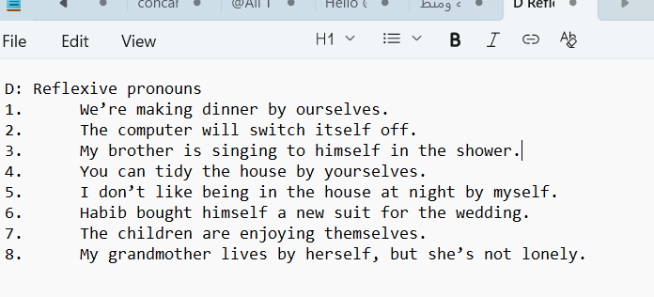
Definitions:
A hill that is not steep is gentle.
Something that is extremely beautiful or attractive is stunning
Something that people say is excellent or wonderful is terrific.
Something that is done with special skills and information is expert.
Something that is made with no problems or mistakes is perfect.
Question Two: Vocabulary
He’s a widower.
He’s my brother-in-law.
She’s a widow.
She is an only child
He is my second cousin.
She’s the oldest sibling.
They’re twins.
B: Pronouns
I can’t find my phone anywhere.
Everyone loves Asma.
I’m looking for something to give to Mum on her birthday.
Does anyone want to go with me to the match tonight?
I’ve got nothing to do.
Somebody phoned you a few minutes ago.
C: Choose the correct words
I haven’t got anything to say to you.
Is there anywhere else you’d like to visit while you are here?
There’s nothing to do here.
I want to go somewhere exciting next year, like India.
Do you know anybody here?
Listen, everyone. I have something important to tell you.

