The Ministry of Education
The Education Directorate of
School---------------------
Final Exam- Second Term
Class: Fourth Grade (Action Pack 4) Material: English Language
Instructor: Date: 1 \6\2018
Time: One hour. أجب عن جميع الأسئلة المذكورة
Name: .......................................................................................................................................Section :(..................)
PART ONE
Question One: Reading Comprehension (10 points)
-Read the following text carefully and then answer all the questions below:

We must plant more trees .Trees are very important .Trees are home for many animals and birds .They give us shade in the summer . They clean the air Trees give us wood and paper
Every year on 15th January children plant trees. It is an- important day. We sing song, we take photos, and make videos. We watch the trees grow.

- Are trees important?---------------------------------------------------------------------------------------------------------------------------------------------------------------------------------
- Where do many animals and birds live?---------------------------------------------------------------------------------------------------------------------------
- How do trees help us when it is hot?-------------------------------------------------------------------------------------------------------------------------------
- What trees give us?
- -------------------------------------------------------------------------------------------------------------------------------
5- What happens on 15th January ?------------------------------------------------------------------------------------------------------------------------------------------------------------------------------------

PART TWO
Question Two: Focus on Vocabulary (9 points)
a- Read and complete the sentences: (5 points)

Bridges - old - birds - big - Madaba

1- Last week Kareem and Samira went to---------------.
2- The map is very-----------------and very------------.
3- They saw----------------over the Jordan River.
4- Kareem and Samira saw ----------------and animals on the mosaic.

Question Three

B. Order tips of planting a tree: (4 points.)

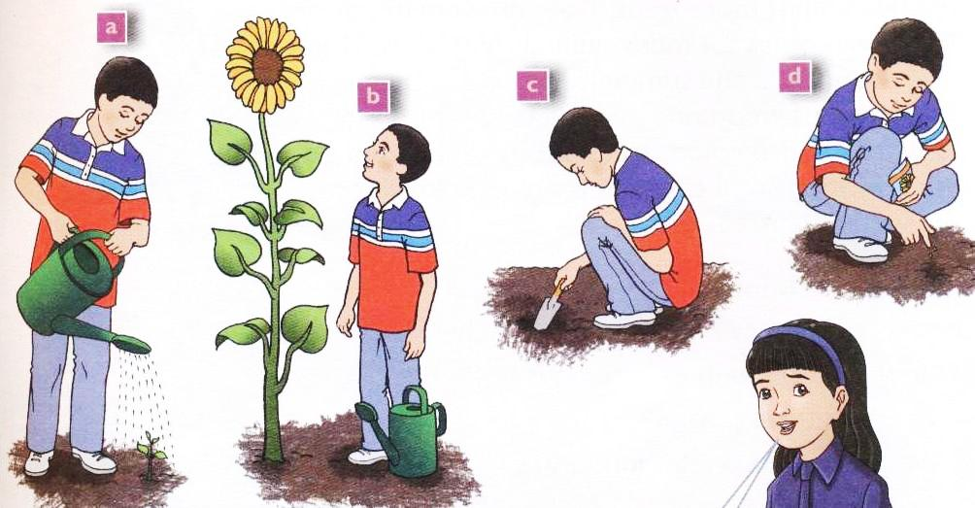
- ______ You must dig a hole.
- ______ Put a seed into the whole.
- ______ You must water it every day.
- ______ Wait for the flower to grow.

PART THREE
Question Four: Focus on Language and Structures (10points)

a--Choose the answer from those given to complete each (10 points):-

1- Jupiter is the ----------planets.
a-biggest b- smallest c- bigger

2The planetarium is the------------room in the museum.

a-biggest b- darker c- darkest

3- ----------can you see in the museum?

a-when b- what c- where

4- - -----------is your brother?
a-who b- when c-what

5- ----------do you live?
a-what b- where c- when

6- Yesterday I ------------the library.
a-visit b- visiting c-visited

7- I didn't ----------football last Friday.

a-play b- played c- playing

-8- Ali is the----------------pupil in the class.
a- tall b- taller c- tallest
9-What ---------------you do yesterday
a- do b- did c- does
10- Kareem------------------------an old coin
a-find b- found c- founding

b- Complete the table: (4 pts.)

Present | past
find
 | bought
 | saw

Question Five - Match sentences with the pictures: (2 pts)

Went to the museum - had / meal / restaurant

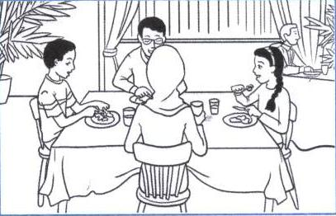
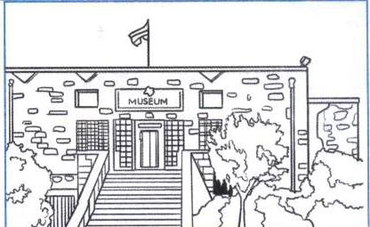

Question Six a--Complete please:- (2points)

Ph wr kn

1- ele-------ant.
2-------ite.
3--------ee .
4--------one.

b- -Answer the following questions :- (3 points)

1- What is you name?
………………………………………………………………………………………………………….
2- Where do you live?
…………………………………………………………………………………………………………….
3- How do you come to school?
………………………………………………………………………………………………………………

THE END
WITH MY BEST WISHES

