Name:--------------------- Second English Exam Class:7th grade
Speaking:- Look at the picture and describe: ( / 6)
/ 20

Samer is standing in the middle .He is the ---------------- (fat ) of all. He is the --------------
( pleasant) one in the three of them.

Shelock Holmes was --------------------- ( professional ) than Poirot
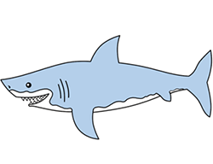
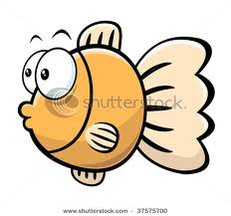
The Shark is -------------------- (big) than the fish.

Answer the following:-
1.Who is your favourite Detective and why ?--------------------------------------------------------------------------------
Reading: Read the following text and answer the questions below:- ( /4 )
Miss Marple is less famous than Holes or Poirot ,but more pleasant than them .She didn't look like a detective at all. She lived in a small village in the country and she used her experience of life to solve crimes .She was wiser than Holmes because she was older than him . She was the oldest of the three detectives. Holmes was the most famous .His method was observation then making logical conclusions. Mr. Poirot's method was to study the minds of the suspects.


1.Why was Miss Marple very wise?------------------------------------------------
2.How did Mr. Poirot solve a crime ?--------------------------------------------------------------------
3. A best title for this text can be -------------------------------------------------
4.T /F : Sherlock Holmes was older than Miss Marple. ( )

Writing:- ( / 6)
Write the correct word next to each definition: ( solution – merchant –suspect – adventure )
-Person whose business is buying and selling. --------------------------------
-An exciting experience. -------------------------------------
-people think he committed a crime. ---------------------------------------
Complete with the correct past simple.
1. Ali ------------- (forget ) to do his homework.
2. I --------------- ( be ) very happy yesterday in my friend's party.
3. the detective ------------------- ( investigate ) many cases last month.

Listening:- Listen and answer the following: ( / 4)
Complete :
1. The bag will be return to its real --------------------------.
2.The Sheik asked the merchant : Is this the bag you --------------------------------- ?
3. Inside the bag were some jewels and thousands ----------------------------- .
4.T/f : The bag was a round ,grey bag with a white string. ( )

