Department of Education 20
Second Exam- first Term
Class: fifth Grade
Date:
Name: ...................................................................................................................
____________________________________________________________________________
PART ONE
Question One: Reading Comprehension:- (5 points)
-Read the following text carefully and then answer all the questions below

We arrived at the Royal Automobile Museum at five to ten. It's ten o'clock now and the museum is open. We're going to learn about the oldest cars and the oldest motorbikes. The oldest car is more than one hundred and twenty years old. The old motorbike is more than one hundred years old.

1- When did they arrive to the museum?
.........................................................................................................................
2-What are they going to learn about?
.........................................................................................................................
3- The oldest car is more than:-
a- 120 years old b- 100 years old
4-commplete
The ………..motor bike is …………..than one hundred years old..
Question Two: Focus on Vocabulary 5 points A. Look, read and choose: (2 points)
1. He is kind:-

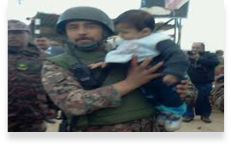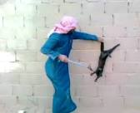
a. b-. c.
2. Old women sewed traditional costumes.

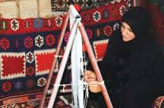
a- b- c
-

B. Read and complete:
(3 points)
evening - morning - Collection - motorbikes
1. The museum opens in the ………………………………………
2We’re going to learn about the oldest cars in the…………………………….
3. You can see ……………………… in the museum.

PART THREE
Question Three: Focus on Language and Structures (5 points)
A. 1- Complete the following comparative sentence :- ( 2 marks)
A- Ali ………………………..to the park last week (go)
B- Scientist works in………………….( lab / park / school )
2- Correct the verbs between brackets:-(3 marks):
A- She .......................... Aqaba next weekend.(go)
B- ........... you........... to Petra last year? (go)
C-He .............. football last night ( Play)
B. 1-Write the correct time in front of each picture(3points)
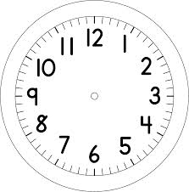

Question Four: Focus on (2 points)

A. Write (3 points)
1- Where does a teacher work?
--------------------------------------------------------------------
2-Wher did you go last week?
---------------------------------------------------------------

