Name : firs exam – 3rd grade 16 - 3 -2018
- Match : (10 points)
Museum | 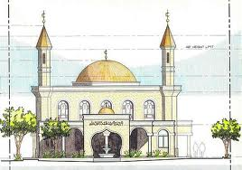
Theatre | 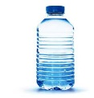
Restaurant | 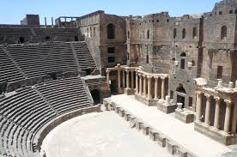
Mosque | 
water | 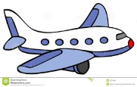
Bus | 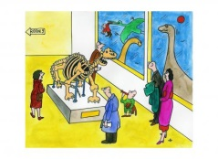
Hat | 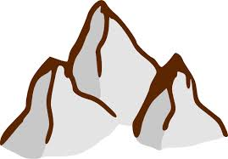
Plane | 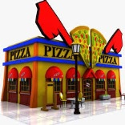
Mountain | 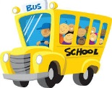
Train | 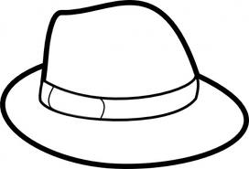
2) write (must or mustn’t ): (6 points)
1. we _____________ in the class.
2.we ______________do our home work .
3. we_____________ run in the bus.
4. we ______________ forget our books.
5. we ______________help our mum .
6. we ______________listen to our teacher.
3)circle: (6points)
1.___________ two cats.
a. there are b. there is
2. Ali __________ student.
a. is b. are
3. is the cat swimming?
a. no, it isn’t b. are
4. we go to the_____________ to pray.
a. school b. mosque
5. there is _____________ in the station.
a. train b. plane
6. you must___________
a. shout in the class b tidy your room.
3) write: (3points)
You must get up at 6:00 o’clock
________________________________________________________________________________________________________________________________________________________________________________________________________________________

