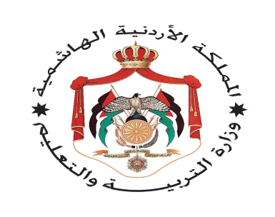
English language Exam
Second Semester
First Exam
----------------School
Name:- Day:-
Class:-4th Grade Date:- / /2015
1-Read the following text carefully ,and answer the questions :- (5 points)
Dear Ali,
My favorite museum is the Children’s Museum. Its in Al-Hussein National Park in Amman .It’s the biggest children museum in the Middle East. There is a library, a theater a restaurant and a shop. My favourite room is the planetarium. Come and fun!
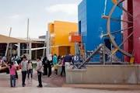
1- Where is the Children’s Museum?
---------------------------------------------------------------------------------------------------.
2-Where can you read books in the museum?
-------------------------------------------------------------------------------------------------.
3-Where can you learn about the planet and the stars ?
-------------------------------------------------------------------------------------------------.
4- Where can you buy food?
--------------------------------------------------------------------------------------------------.
5- Have you ever visited the Children’s Museum?
------------------------------------------------------------------------------------------------.

2-Choose the suitable item to complete of the following sentences :-
(5 points)

Fountain - river - forest - stadium - stage
1-I can swim in the-------------. 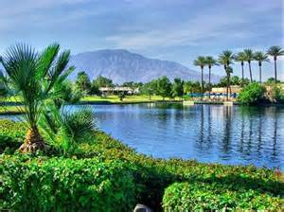
2-In th past there wasn’t a-----------------------. 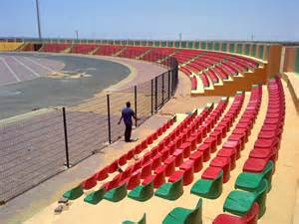
3-There is a----------------------------in the Children’s Museum. 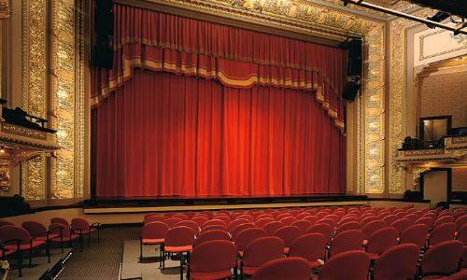
4- Wild animals live in ---------------. 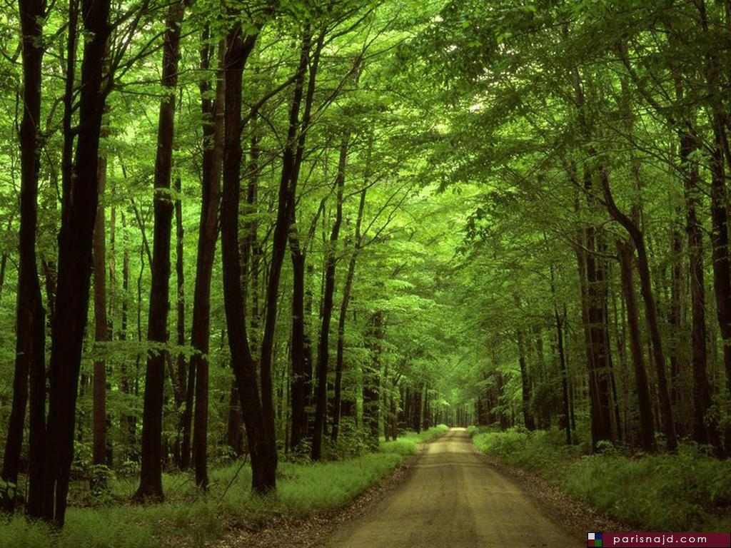
5- There was a big------------------. 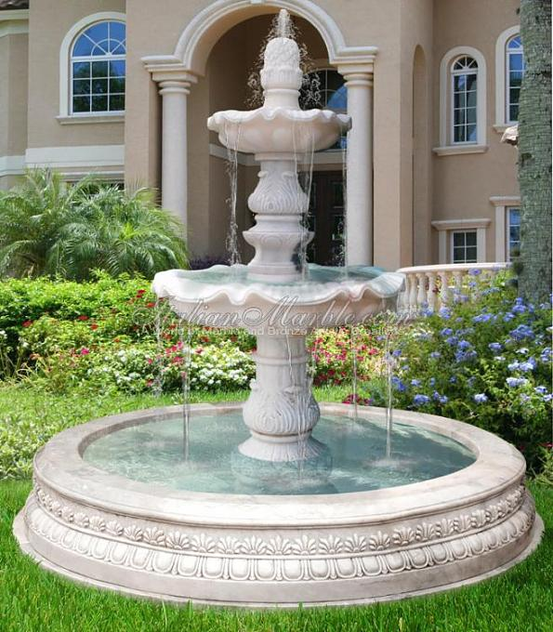

3-Choose the answer from those given to complete each \sentences :- (5 points)

1-On the evening I-------------at the school.
a- am b- was c- wasn’t .
2- The restaurants-----------------here in the past.
a- was b- are c- aren’t.
3- The Roman Theater ------------- here in the past.
a- is b- was c- are
4- Sami is --------------Sameer.
a-tall b- taller than c- tallest
5- Jupiter is the ------------- planet.
a-big b –bigger than c- biggest

4-Read and circle (Yes) or(No) (3 points)
1- Amman was called “Philadelphia “in the past. Yes/No
2- The sun is a planet. Yes/No
3- Jerash is the biggest city in Jordan. Yes/No

5-Answer the following questions:- (1 point)
- Where do you live?
- Which is the fastest animal?
6-copy please: :- (1 point)
In the past there were big forest in Jordan.
---------------------------------------------------------------------------------------------------------------------------------------------------------------------------------------------------------------------------------------------------------------------------------------------------------------------------------------------------- 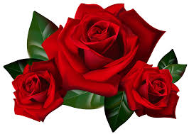

The End
With my best wishes

